

**University Of Balamand**

**Faculty of Engineering**

**Advanced Electric Machines**

**Dynamic Analysis of Symmetrical Induction Motor  
Dynamic Analysis of Synchronous Generator  
Analysis of the Combined model**

Presented to: Dr. Maged B. Najjar

Presented by: Kifah DAHER   
 Martine CHLELA

Date: 1-02-2013

Table of Contents

Abstract: 3

Induction Motor: 4

Theoretical background: 4

Simulation part: 9

A- Free acceleration From Stall: 10

B- Acceleration from Stall with load torque increasing from 0 to 10 N.m: 17

C- Step changes in Load Torque: 23

D- Step change in Stator Voltage frequency: 28

E- Step change in the stator voltage magnitudes: 34

Synchronous Generator: 40

Theoretical background: 40

Simulation part: 45

A- Synchronous Generator with a step change in the Torque: 46

B- Step change in input torque (-50 N.m.): 53

C- Various step changes in input torque: 56

D- Step change in rotor speed: 59

E- A change in the electrical load: 63

F- Change in the field characteristics: 66

Combined Model: Synchronous Generator feeding Induction Motor: 71

A- Synchronous Generator feeding induction motor for a Torque increase: 72

B- Synchronous Generator feeding induction motor for a decrease in motor speed: 79

Conclusion: 85

Table of figures: 86

References: 88

# Abstract:

This project is done to analyze two types of electric machines: the three-phase Symmetrical Induction machine and the Synchronous machine. The symmetrical induction machine although known as induction machine usually converts electric power to mechanical work, thus the name induction motor. The synchronous machine often is used to convert mechanical power into electrical so it is a synchronous generator.

This project is divided into three major parts; the first part is the dynamic analysis of a three-phase Induction motor with different scenarios to better observe and interpret the behavior of the machine. The second part investigates a three-phase synchronous generator where different scenarios are done in order to analyze the performance of the machine in different cases. The third part consists of the combined model; a synchronous generator feeding an induction motor and different cases of tasks are manipulated to examine the overall system.

# Induction Motor:

Symmetrical machines can operate as either a motor or a generator. Although known as induction machines, they are often used to convert electric power to mechanical work; motor mode. Three-phase induction motors are used in large-horsepower applications as pump drives, steel mill drives. The induction motor is the workhorse of the electrical industry. As generators, induction machines have limited use; wind turbine and low-head hydro applications.

To conduct analysis, in induction machine it is necessary to perform a change of variables or transformation which once done eliminates the time-varying mutual inductances which occur because of windings in relative motion. The change of variables done is by replacing the rotor windings with fictitious windings fixed to the stator as in a transformer with two windings when one referred to the other.

## Theoretical background:

A two-pole three-phase induction machine is shown in figure 1; it has three identical, sinusoidally distributed stator ,rotor, windings, the magnetic axes of which are displaced by 120° from each other.

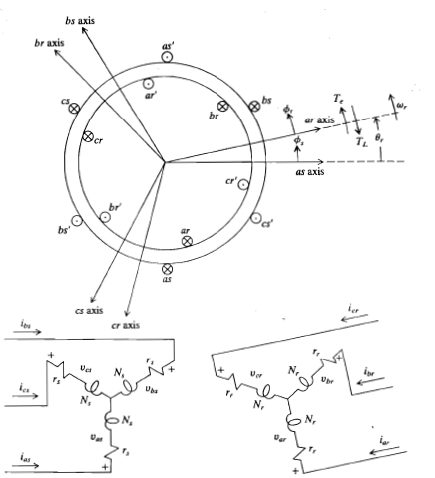

Figure 1: A two-pole three-phase symmetrical induction machine

Voltage equations are as follows:  
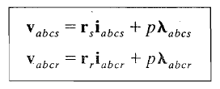   
where  
 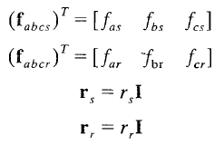

rs is the resistance of the stator windings whereas rr is the resistor of rotor windings. I is a 3x3 identity matrix. Ƒ can represent voltage, current or flux linkage.  
The flux linkage equations may be written as:  
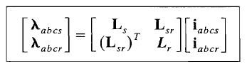  
where  
 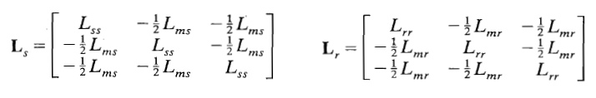  
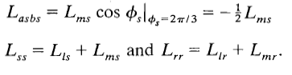  
and   
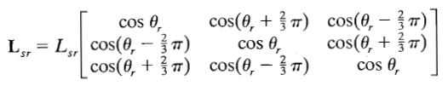 where 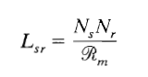  
by referring all rotor variables to the stator windings the following ration is to be added:  
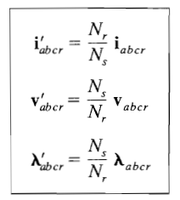   
thus voltage equations becomes:  
 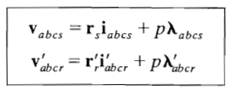 where 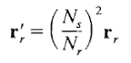  
the flux linkage equations may be written as follows:  
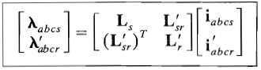 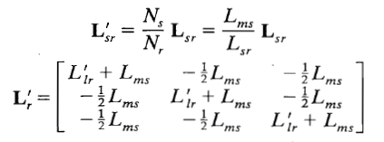

and 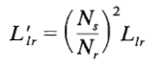.

The electromagnetic torque, positive for motor action is related to the rotor speed and given by the following expression:

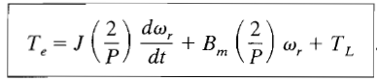

As we have mentioned before, we need to change the rotor variable of the machine in a way to be fixed at the stator. So we need to derive the machine’s equation in the stationary reference frame. Since there are three stator variables ƒas, ƒbs & ƒcs and three rotor variables ƒ’ar, ƒ’br & ƒ’cr it is necessary to replace both stator and rotor variables with substitutes. It is a transformation from **abc** to **qdo**; the addition of the third fictitious variable ‘o’ which is the so called zero variable or zero quantity plays no role in the analysis in a balanced operation of a three-phase induction machine. And since we are working on a balance operation symmetrical induction machine this values is assumed to be a zero quantity.

The change of variables for the stator variables is:  
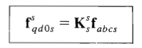 where   
the transformation matrix and its inverse are the following 3x3 matrices:  
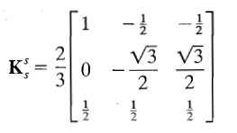 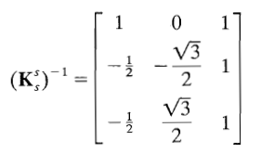  
the change of variables which transforms the rotor variables to stationary reference frame is:  
where   
the transformation matrix and its inverse are the following 3x3 matrices:

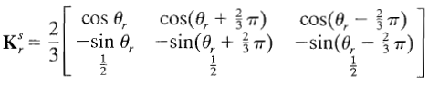 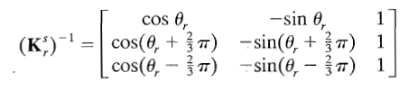  
Where the notation is the angular displacement between the ar and the as axes.  
One property of the zero quantities can be noted from transformation; both ƒ0s and ƒ’0r are identically equal to zero if the three-phase sets are balanced (which is our case). A raised index is generally not associated with zero quantities since these variables are always in same frame of reference as the actual phase variables.

The three-phase machine’s voltage equations in the stationary reference frame may be written in terms of inductances independent of the relative motion variation  
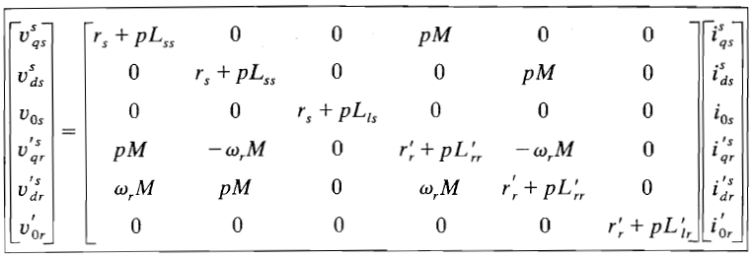Where 

## Simulation part:

To investigate the three-phase symmetrical induction machine (asynchronous machine) we have used Simulink/Matlab and the SimPowerSystems toolbox where in the Machines library model of the induction machine is represented by the Asynchronous machine block:

We have investigated a 5 hp, 460V , 60 Hz , 3600 rpm two-pole induction motor for various condition. The specifications of the selected motor are the following:

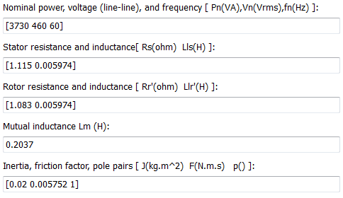

Figure 2: Induction motor parameters

The machine is tested under various scenarios to investigate the steady state and the dynamic machine performance. In each condition results are displayed and analyzed.

### Free acceleration From Stall:

### 

Figure 3: Simulink diagram for Free Acceleration Scenario

In figure 3 the Simulink diagram is shown for the free acceleration scenario. The mechanical torque load (Tm ) is set by a step function and will remain zero all along the simulation time.

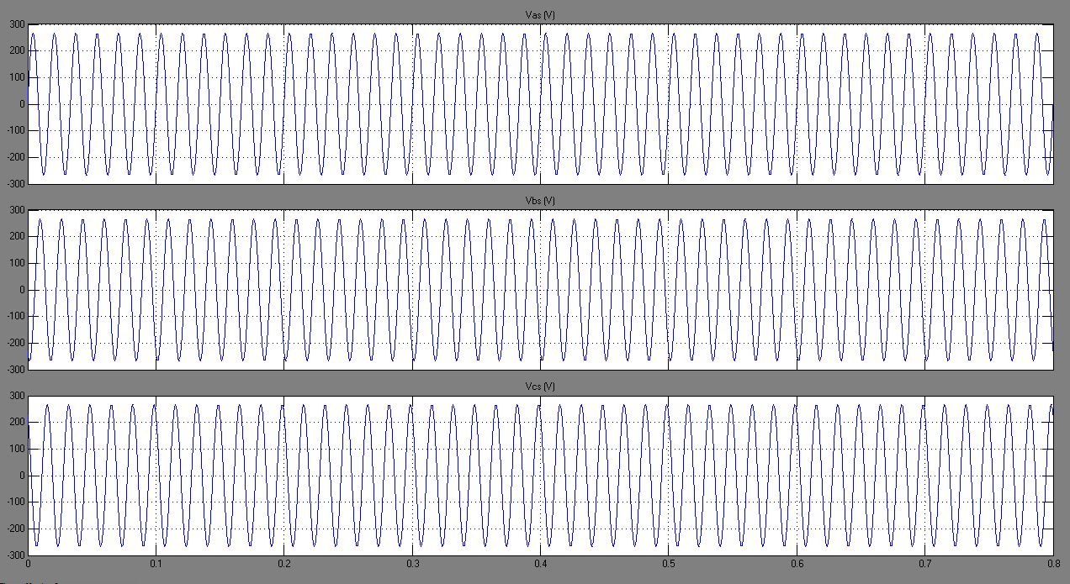

Figure 4: Stator Voltages

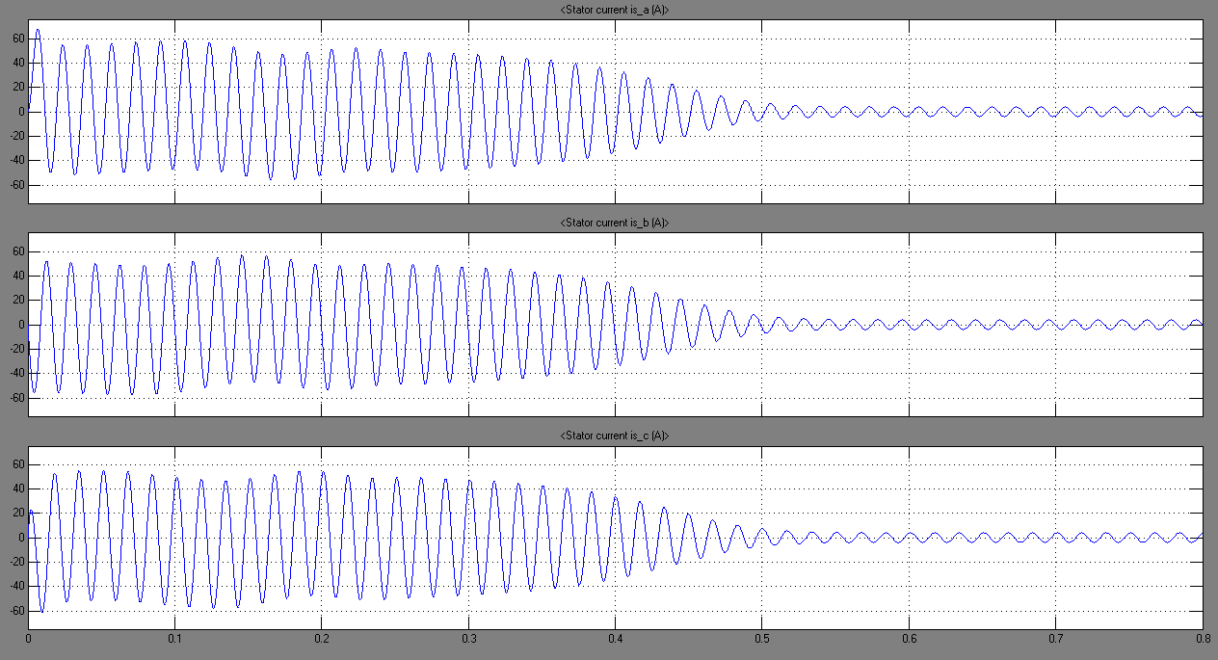

Figure 5: Stator Currents

Figure 4 shows the stator voltages a,b &c that have a peak value of they are sinusoidally distributed displaced by 120° and supplied by three voltage sources. The machine accelerate from stall with zero load torque: As shown in figure 5 at the first 0.5 seconds the motor absorbs current to induce a rotation from stall, once it start running the currents in steady state became negligible it assumed to be zero if we neglect the friction and windage losses.

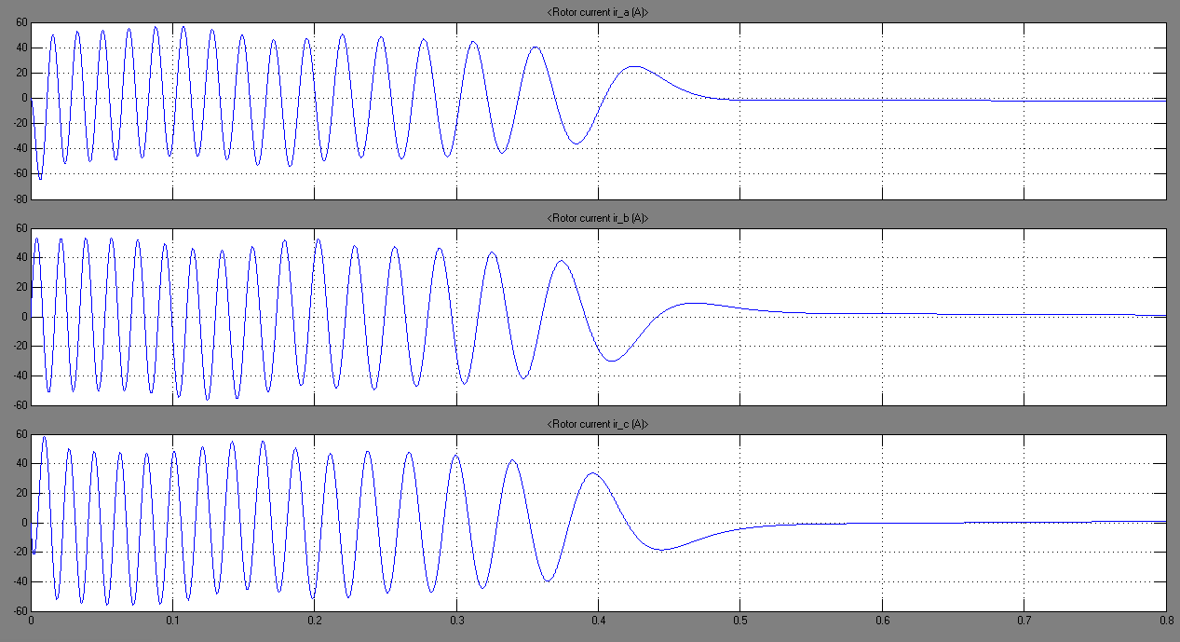

Figure 6: Rotor Currents

Figure 6 shows the current induced in the rotor windings. These current are of high values at the starting transient period (0.5 sec) then stabilized to a value near zero. We note that the stator and rotor current does not vary in the same frequency since they are not in a common frame of reference. The variation in the envelope of the currents during transient period is obvious. This is caused by the interaction if the transient offset in the stator currents with the transient offset in the rotor currents and the fact that the stator and rotor circuits are in relative motion.

The transient offset of the rotor and stator currents is evident which give rise to the transient pulsation in the electromagnetic Torque as shown in figure 7 .

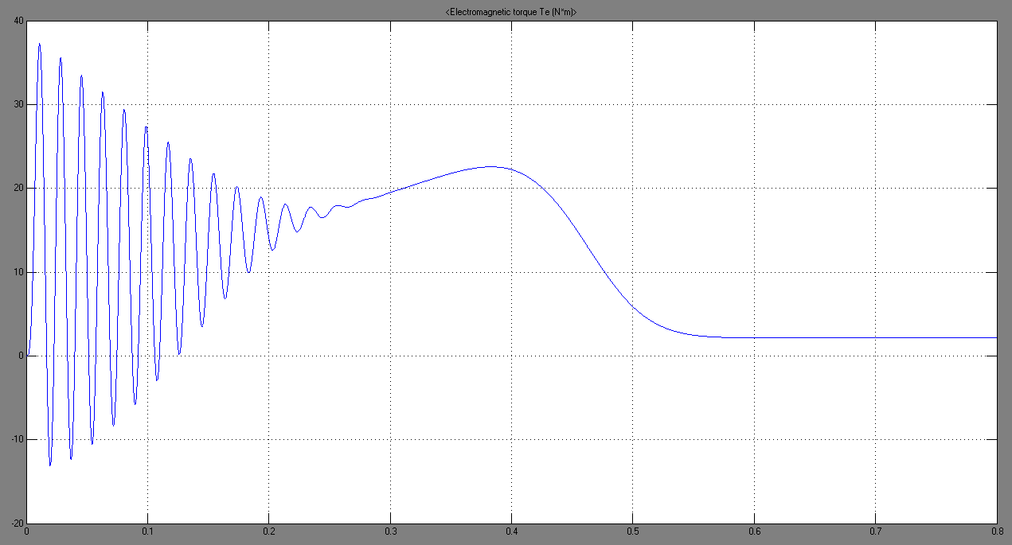

Figure 7: Electromagnetic Torque

The pulsation in the electromagnetic Torque which is the frequency of the stator voltages (60 Hz) disappears when the transient offset in the stator and rotor currents disappear.

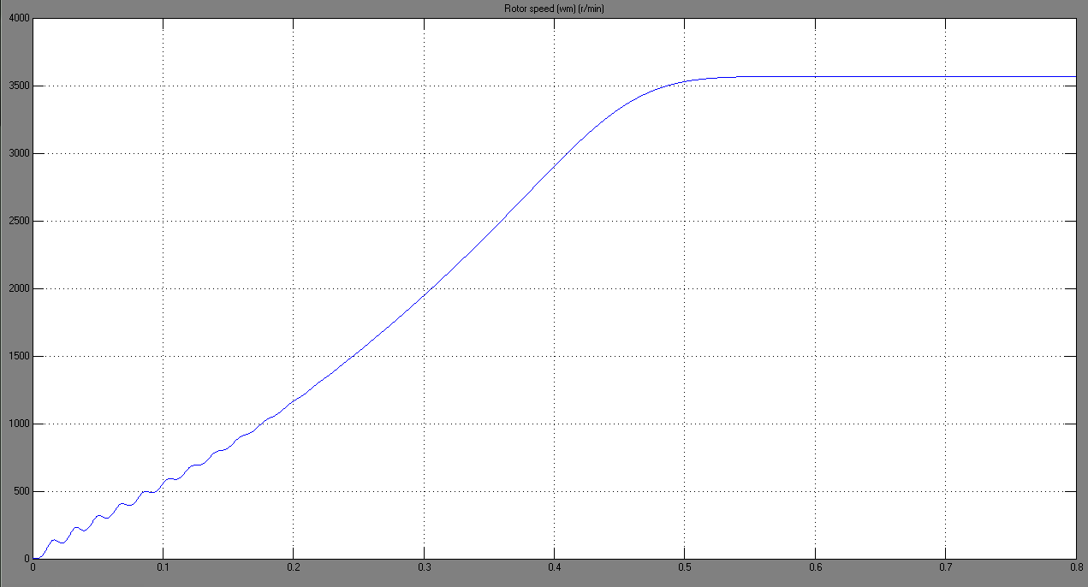

Figure 8: Rotor Speed (r/min)

Figure 8 shows the rotor speed ωm shape in r/pm. For the two-pole 5hp machine, synchronous speed is 3600 r/min where ωrm = the electrical angular velocity of the rotor is ωr which is arround 377 rad/s or 3600 r/min at synchronous speed. The machine accelerates from stall with zero load torque and since friction and windage losses are not taken into account, the simulated machine accelerates to synchronous speed. In practice, friction and windage losses would exist and the machine would not reach synchronous speed. It will operate at a speed lightly less than synchronous, developing an electromagnetic torque Te sufficient to satisfy small torque load due to friction and windage. Simulink take this factor into consideration, in figure 8 we can realize that after the transient part the machine will run at a speed lightly less than synchronous speed 3600 r/min and in figure 7 the electromagnetic torque Te is greater than zero this to satisfy the small torque load due to friction and windage.



Figure 9: Torque vs Speed characteristic during free acceleration

Figure 9 shows the electromagnetic torque Te versus speed characteristic during free acceleration. For small-horsepower machines as in our case, the steady state torque-speed characteristic is essentially the average of the transient torque-speed curve during the time the transient pulsation torque exists as shown in figure 9. The inertia of the rotor and connected load is generally large enough to prevent the pulsating torque from causing significant variations in rotor speed. The electromagnetic torque pulsates until the synchronous speed is reached (3600 r/min) it stabilizes to certain value.

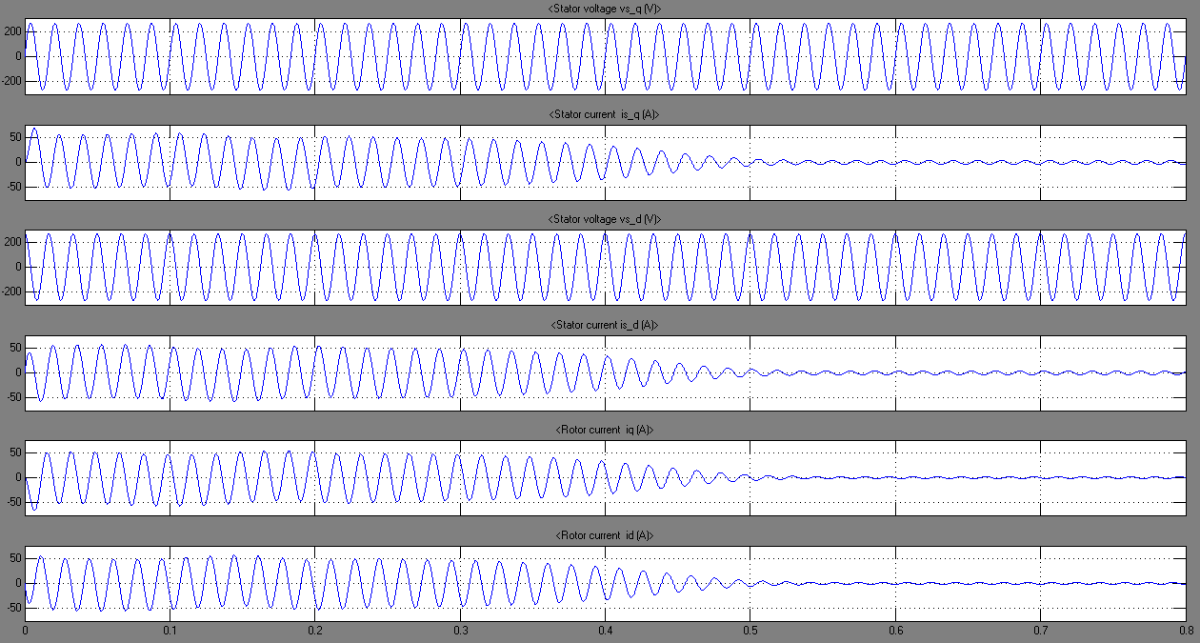

Figure 10: Rotor Currents, Stator Current and Voltages in stationary reference frame

The change of variables transforms the rotor variables to the stationary reference frame. In particular,  became  and became  in the same manner and became and ; and  and are transformed to  and . Because of this change of variables, all machine variables are in common frame of reference and, therefore, will vary at the same frequency during steady state operation. Figure 10 shows the stator voltages and current and the rotor currents in the stationary reference frame variables (qd components). By comparing figure 10 to figure 4, 5 & 6 we can easily see that in the same reference frame the frequency is the same for all signals.

### Acceleration from Stall with load torque increasing from 0 to 10 N.m:



Figure 11: Simulink diagram for an acceleration form stall with load torque

Figure 11 shows the Simulink diagram built to simulate the induction motor during acceleration from stall with torque load increasing from 0 to 10 N.m . We have used a ramped function to increase the torques in a way starting from 0 and reaching 10 N.m at the end of simulation time which is 0.8 seconds. A torque load of this type is typical of a fan load. 10 N.m occurs at synchronous speed.

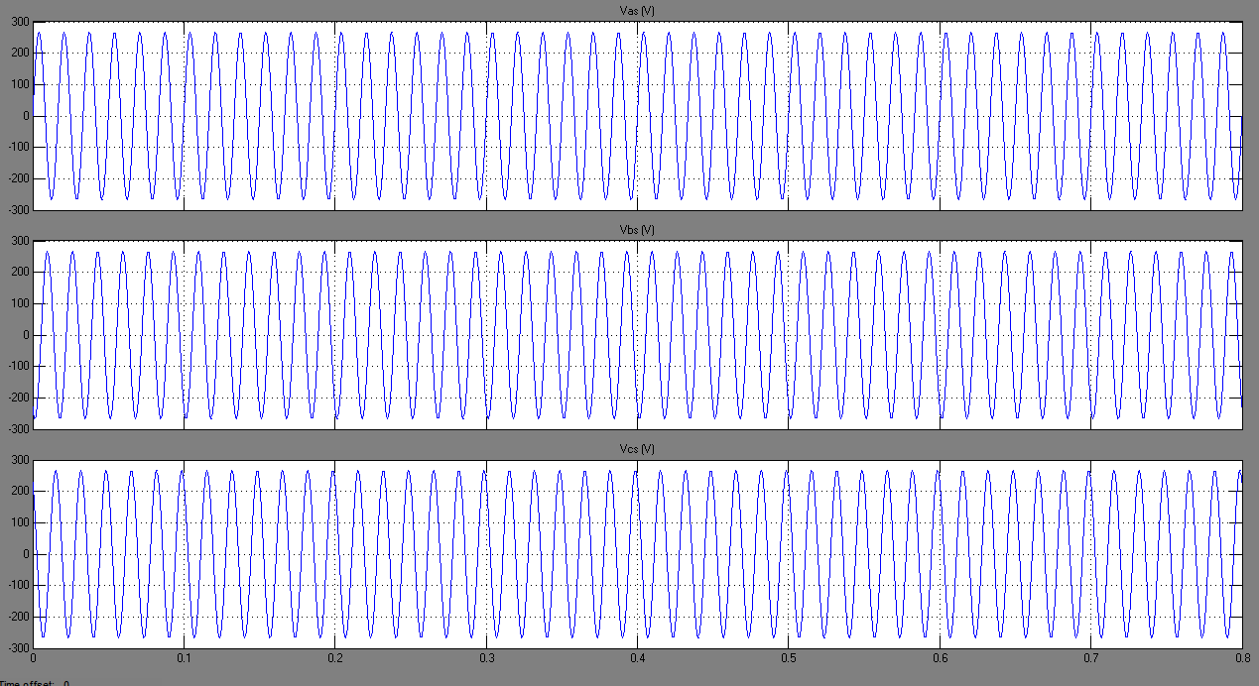

Figure 12: Stator voltages

Figure 12 shows the stator voltage at this scenario. We can clearly notice that there is no change in the voltage aspect of the stator when applying a torque during acceleration. Figure 13 shows the stator currents for acceleration from stall with a torque. After transient period the currents stabilized at a value higher than zero comparing to the scenario A (with no Torque load) and this is due to the fact that the motor is subject to a mechanical load in this case. The currents increase till the end of simulation and that due to the increase of torque load with simulation time. Figure 14 shows the same variation with different frequency since we are not working in the same reference frame.

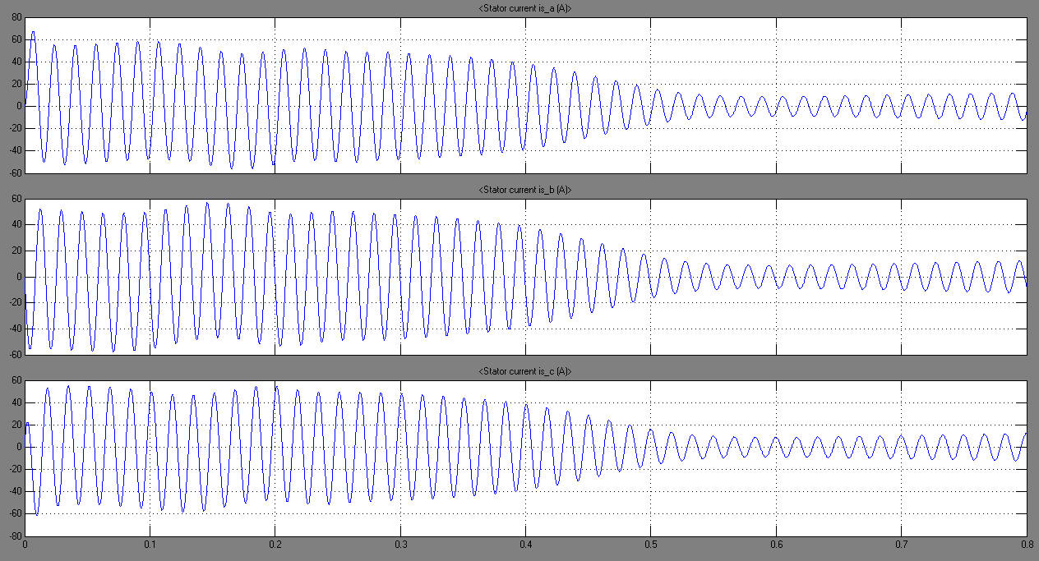

Figure 13: Stator Currents

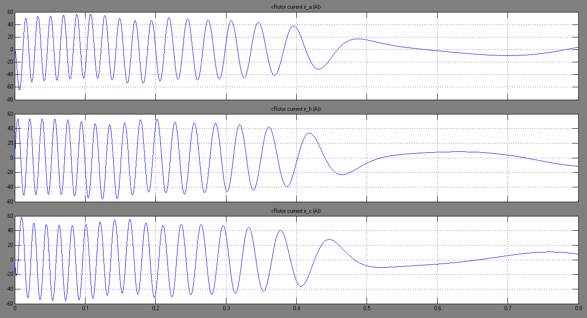

Figure 14: Rotor Currents

Figure 15 shows the rotor currents, the stator currents and voltages in the stationary reference frame. Since we are in a common frame all signals varies at the same frequency (60 Hz) and it is velar that currents are no more negligible at steady state due to the presence of the torque load.

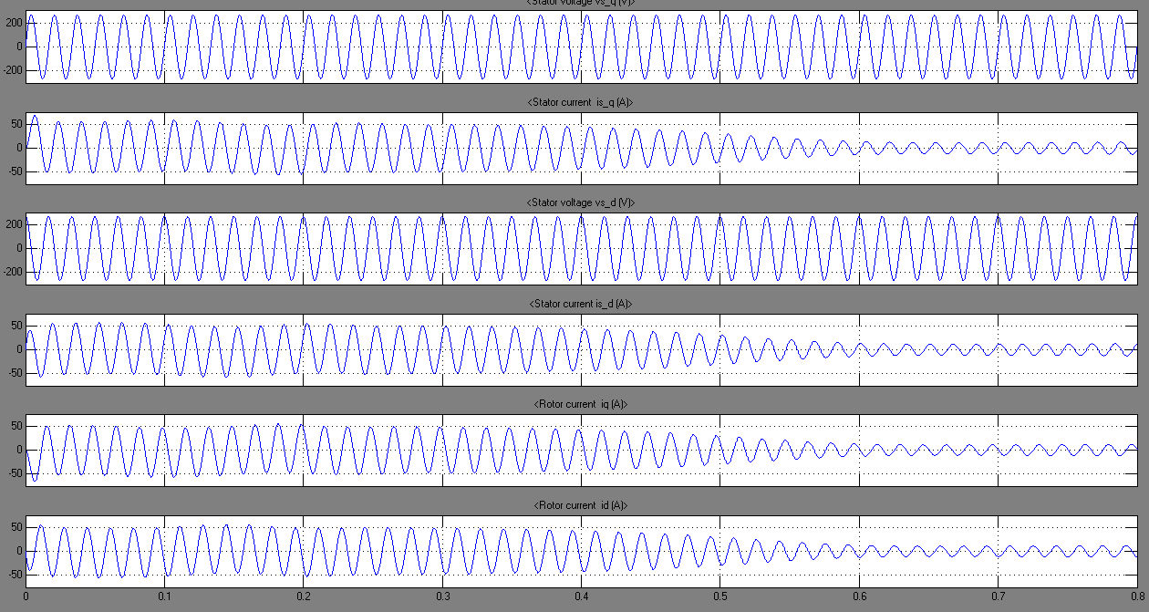

Figure 15: Rotor Currents, Stator Currents and Voltages in stationary reference frame

Figure 16 shown the aspect of the electromagnetic torque Te in this scenario. After the pulsation due to the transient, the torque stabilizes to a value different than the one in scenario A since we have a torque load here. The final value of Te , when synchronous speed is reached, is slightly greater than 10 N.m and that to satisfy the small torque load due to friction and windage. The difference between the electromagnetic torque Te and the load torque TL is the torque that accelerates the rotor, referred as accelerating torque. Acceleration occurs when Te = TL.

Figure 17 shows the rotor speed aspect which is slightly less than synchronous speed.

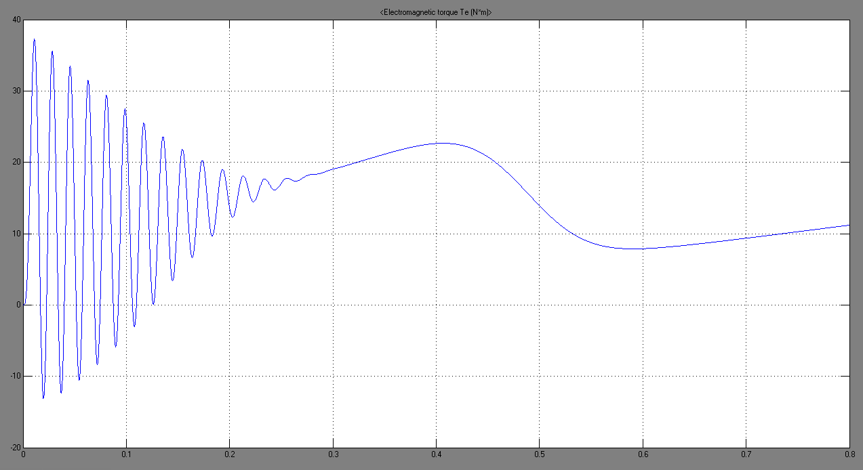

Figure 16: Electromagnetic Torque Te

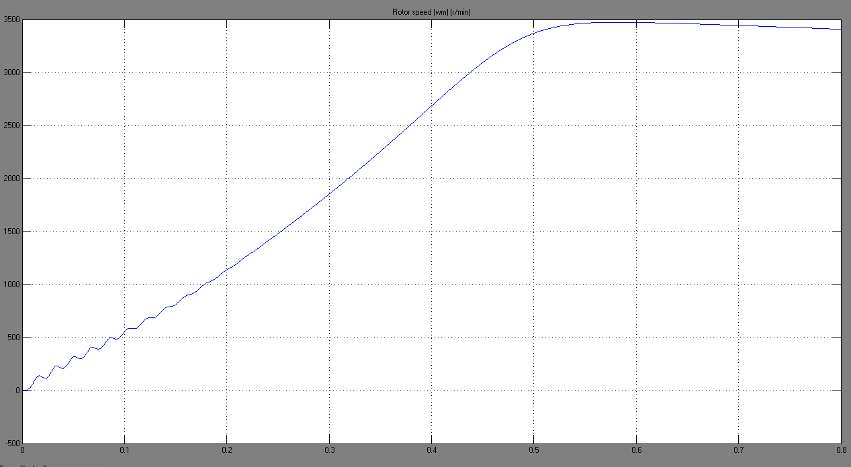

Figure 17: Rotor speed wm

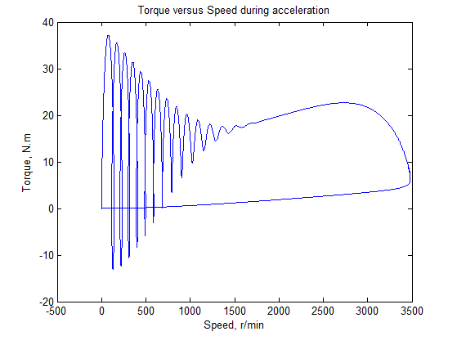

Te

TL

Figure 18: Torque versus Speed during acceleration

Figure 18 shows the Torque versus speed characteristic during acceleration from stall with a torque load varying from 0 to 10 N.m . Comparing to figure 9 the Te versus Speed characteristic is of the same aspect but at the synchronous speed it stabilize to a value around the value of the applied load torque.

### Step changes in Load Torque:



Figure 19: Simulink diagram Step Changes in Load Torque

Figure 19 shows the Simulink diagram built for a step change in load torque. We have used step function to represent this step in load torque change from 5 N.m to 10 N.m at t = 1 second than back to 5 N.m at t = 2 seconds.

Figure 10 shows the stator voltages, as we can see the stator voltages remain untouchables with step increase than decrease in load torque.

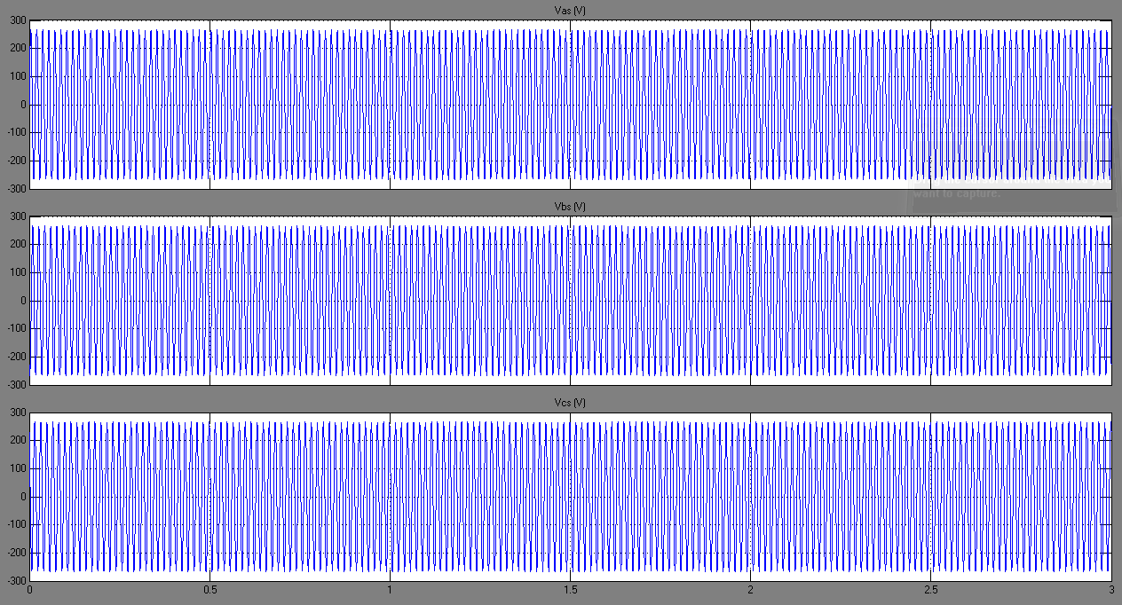

Figure 20: Stator voltages

Figure 21 shows the stator current and reflects the increase in the load torque at t = 1 s from 5 N.m to 10 N.m. This increase in load torque between t= 1 and 2 seconds leaded to an increase in the stator current to supply this load which make sense since during this time the motor need more electrical power to supply the increase of the mechanical power applied at its shaft with a constant speed. Figure 22 shows the rotor currents which increases as well at the time when the load torque increased and decreases again when the load torque is stepped back to its initial value. We note that a change in the frequency of rotor current is realized from t= 1 to 2 seconds.

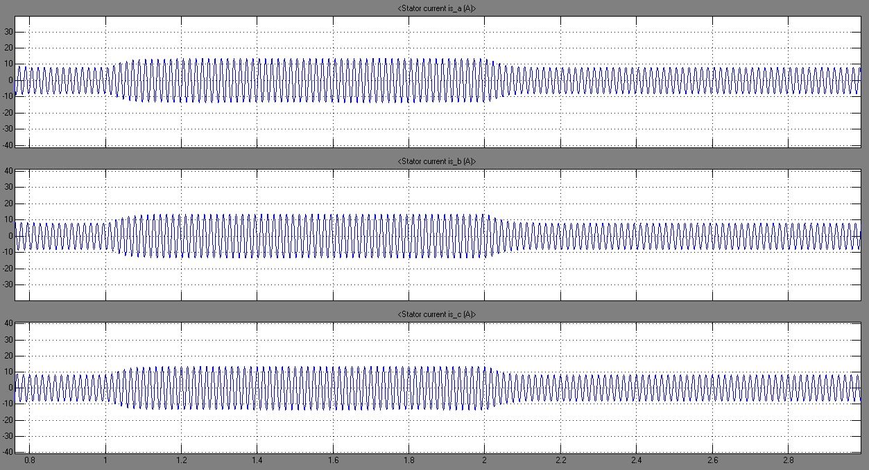

Figure 21: Stator Currents

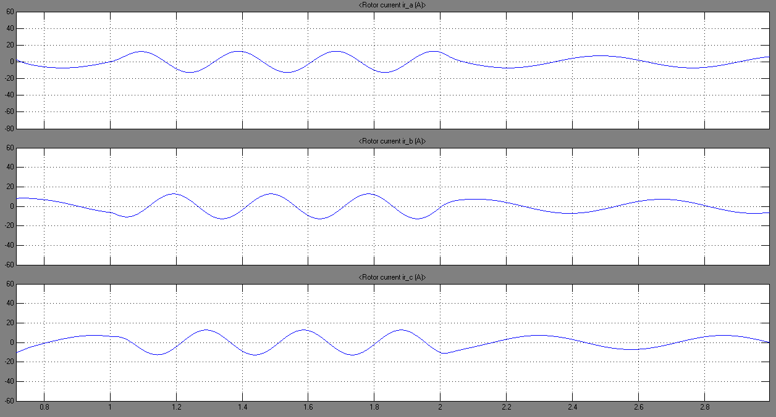

Figure 22: Rotor Currents

Figure 23 shows the rotor currents, stator voltages and current values changed to the same reference frame where we can realize that all signal vary in the same frequency. The increase in currents either in rotor or stator is represented as well as in figures 21 and 22.

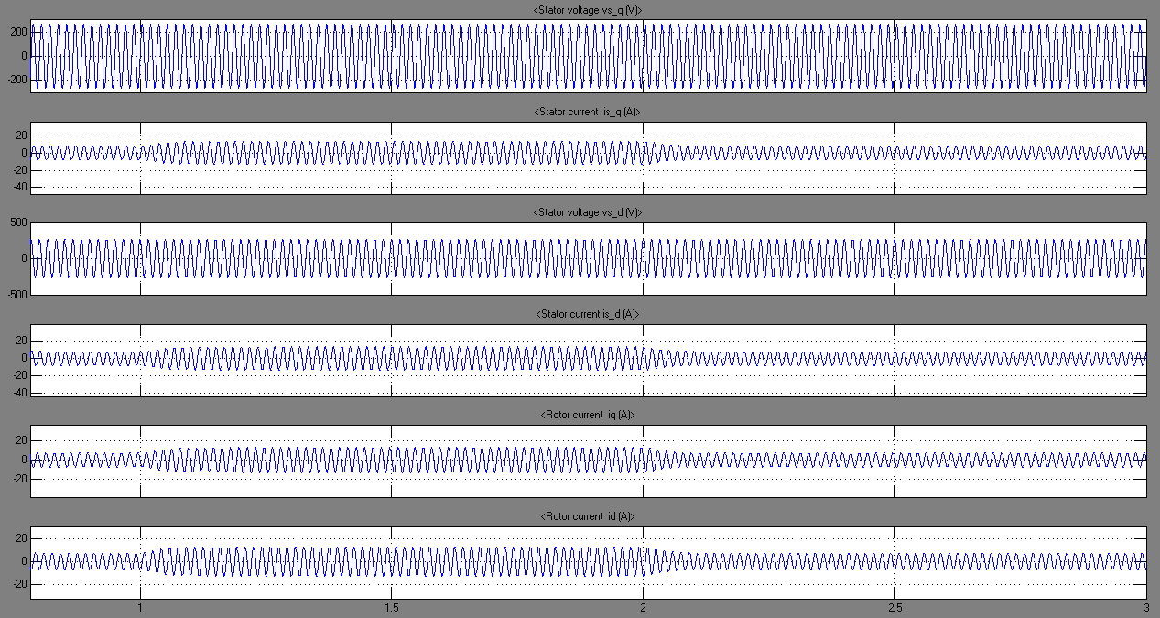

Figure 23: Rotor Currents, Stator Currents and voltages in stationary reference frame

The Electromagnetic Torque Te before the increase in load torque was constant, equal to a value slightly greater than 5 N.m when applying a step increase in the load torque at t = 1s the electromagnetic torque increase facing this increase in order to compensate the increase in the mechanical power. At t = 2s when the load torque TL is stepped back to 5 N.m its initial value the electromagnetic torque decreases to satisfy the applied torque load. The proportional relationship between Te and TL is in conformity with the expression  the difference in values is due to friction and windage losses.

Figure 24 shows this relation between the electromagnetic torque and the load torque change.

Figure 25 shows the rotor speed; once the load torque increased the rotor current frequency increases as it is shown in figure 22. Thus, imply a variation in the rotor speed since rotor currents vary at ωe-ωr. The speed was decreased at t=1s then goes back to its initial value at t=2s.

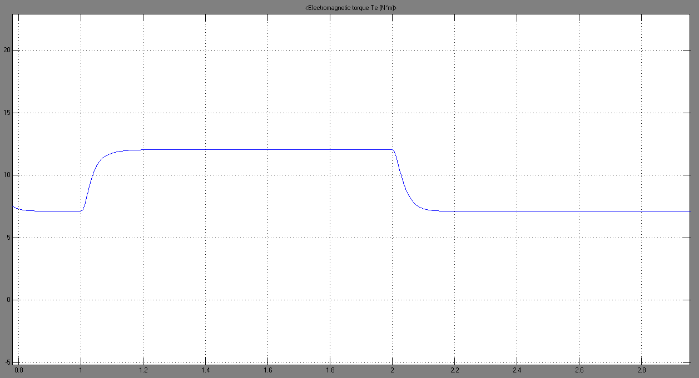

Figure 24: Electromagnetic Torque Te

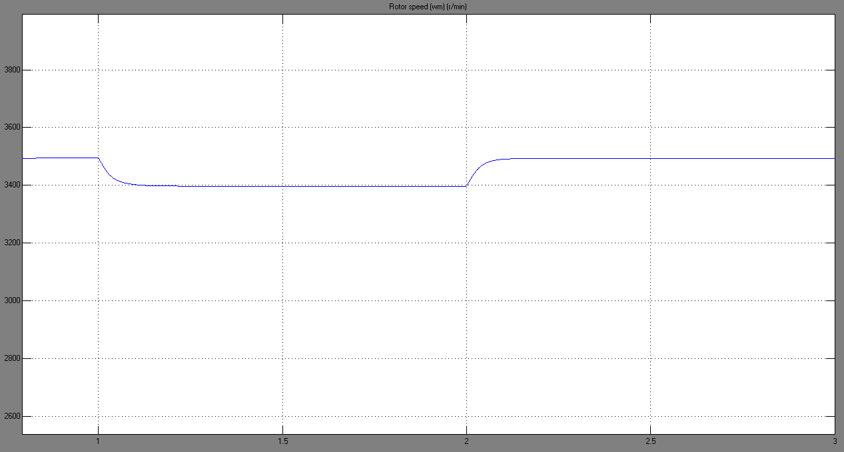

Figure 25: Rotor Speed wm

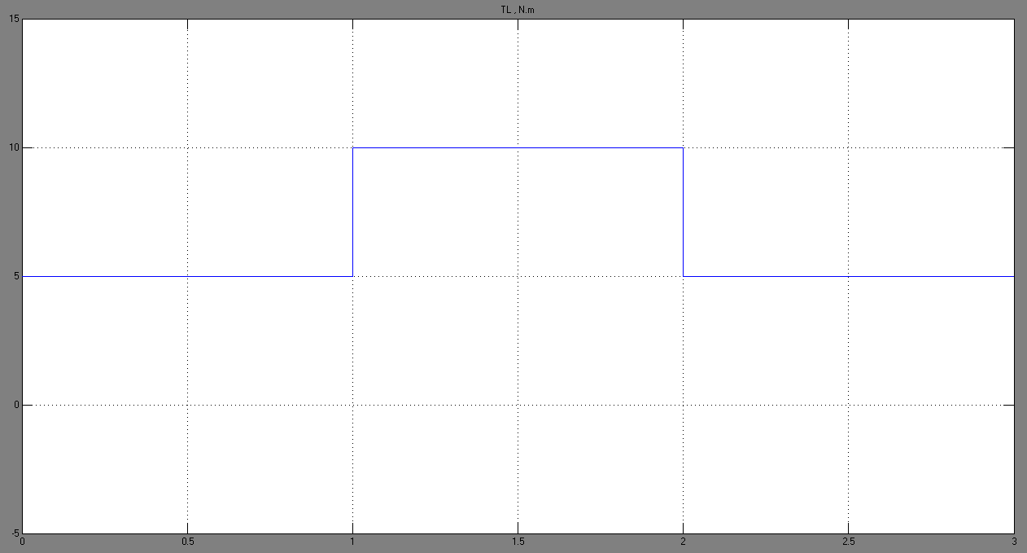

Figure 26: Load Torque TL

Figure 26 shows the torque load behavior during the simulation time.

### Step change in Stator Voltage frequency:

By the mean of a three-phase programmable voltage source, the frequency was step from 60 Hz to 50 Hz at 1.2 sec, and then re-increased to its initial value of 60 Hz at 2.2 sec. During this scenario the load torque was held fix at 5 N.m. Figure 28 shows the stator voltages and represents the frequency change in these voltages. Figure 29 and 30 represent the stator and rotor current respectively. The change in frequency has affected these currents. Once the frequency decreased a small perturbation in the stator and rotor currents is noticed (figures 29,30), whereas larger perturbations are occurred once the frequency was increased to its initial value.

At t=1.2 seconds and once the frequency is decreased the instantaneous torque decreases (figure 31), whereupon the rotor slows down (figure 33) and steady state is reached before the second frequency variation. Once the frequency of the stator voltages is stepped back to 60 Hz t = 2.2 seconds (rated value) the instantaneous torque increases (figure 32), the rotor accelerate so the speed is back to its original value (figure 33) and the original operation condition is reestablished.



Figure 27: Simulink diagram of a Step in frequency

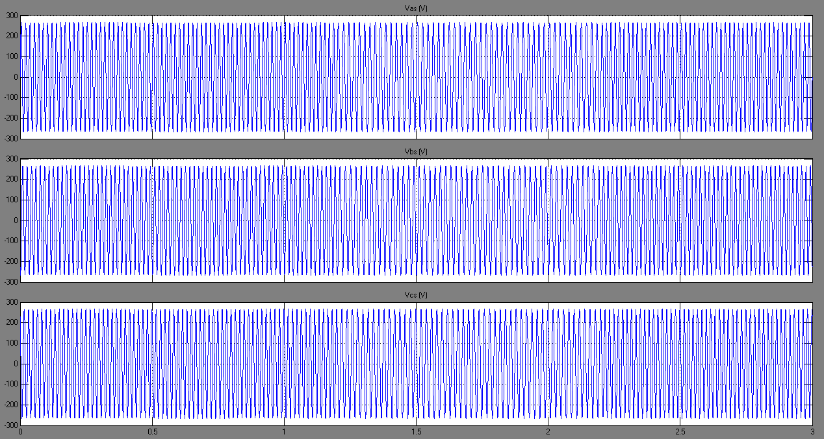

Figure 28: Stator Voltages

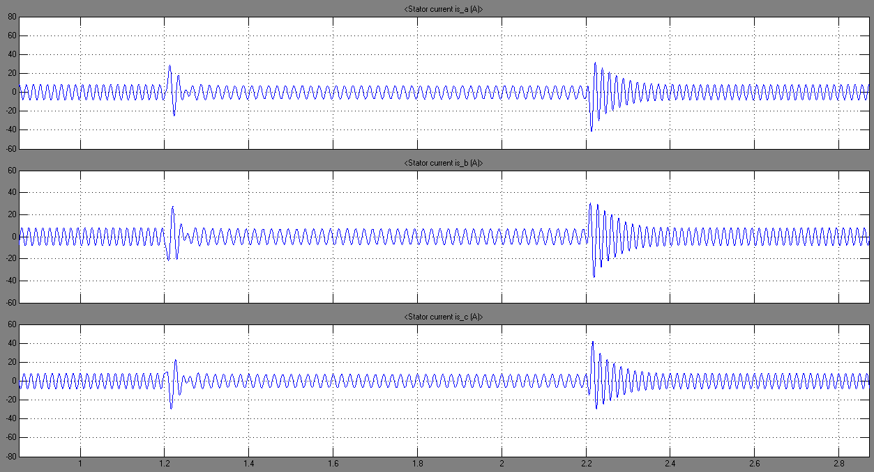

Figure 29: Stator Currents

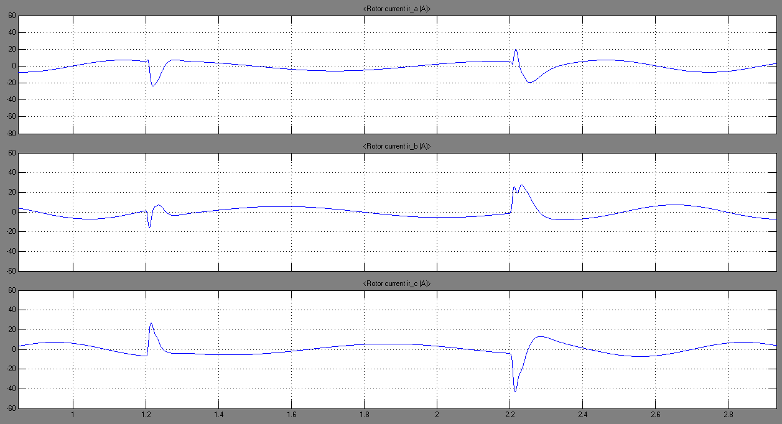

Figure 30: Rotor Currents

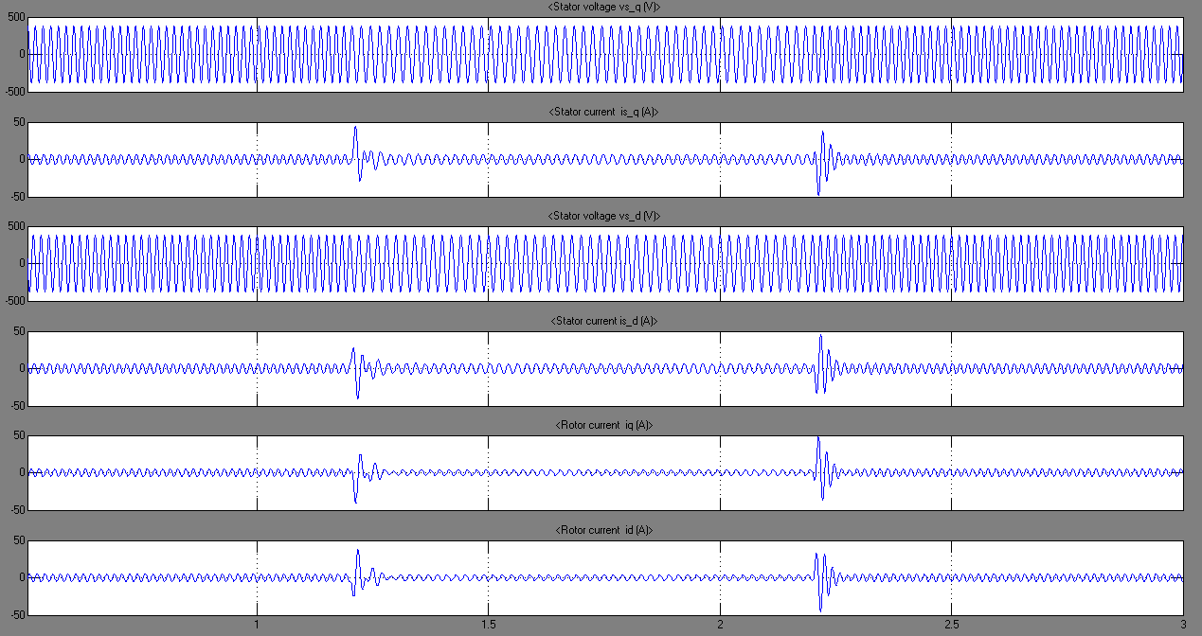

Figure 31: Rotor Currents, Stator Currents and voltages in stationary reference frame

Figure 31 shows the rotor currents, stator voltages and currents in the stationary frame. The effect of the frequency change is noticed on the currents referred to the stationary frame.

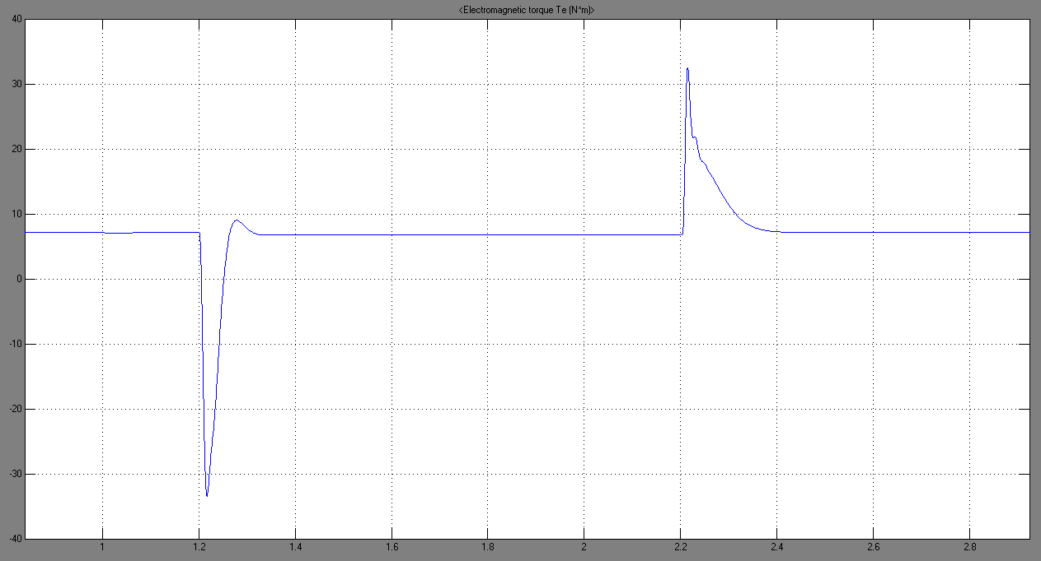

Figure 32: Electromagnetic Torque Te

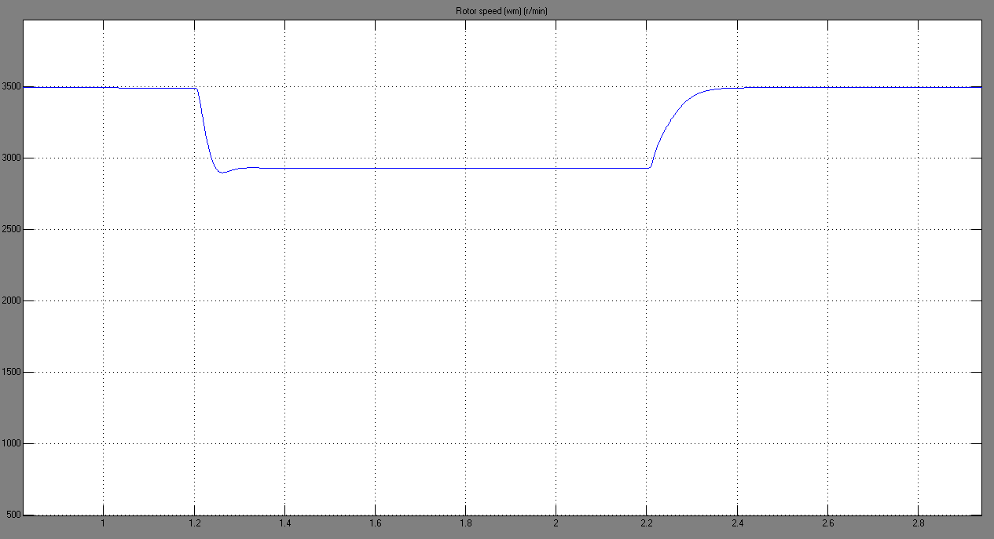

Figure 33: Rotor Speed



Figure 34: Torque versus Speed for Step Change in stator frequency

Figure 34 represents the electromagnetic torque Te versus the speed characteristic for the 50 Hz and 60 Hz operation condition. As we can notice, when the frequency was set to 50 Hz the speed reached, was lower than that observed in the 60 Hz plot.

### Step change in the stator voltage magnitudes:



Figure 35: Simulink diagram for a step change in stator voltage magnitudes

Similarly to the frequency change scenario, a three-phase programmable voltage source has been used in order to perform a change in the stator voltage magnitudes. The load torque remained constant all along the simulation, with value equal to 5 N.m. At t= 1.2 seconds the stator voltage magnitudes was increased by 0.1 pu than at 2.2 seconds when steady state is reached was stepped back to its original value.

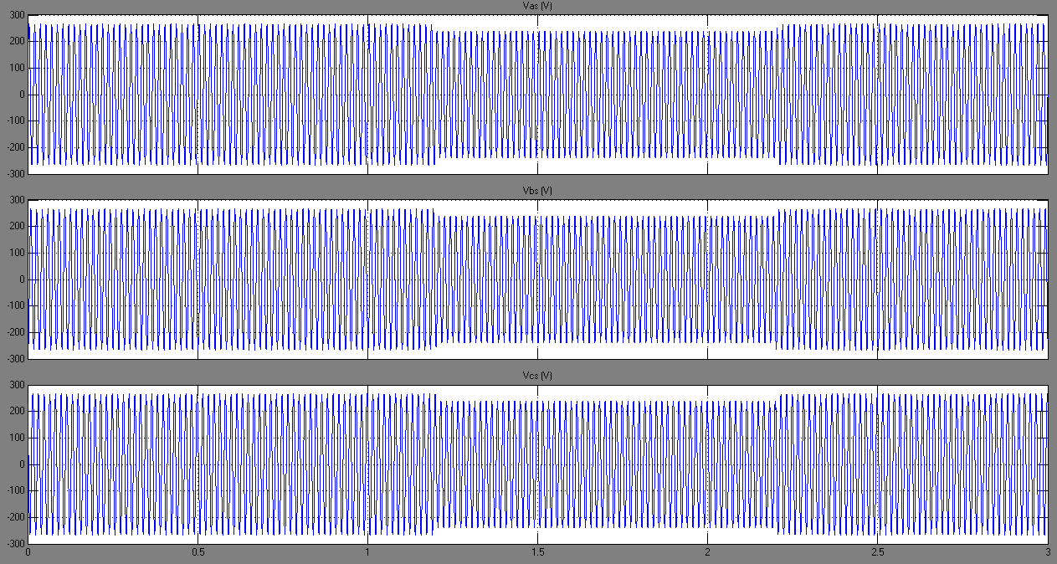

Figure 36: Stator Voltages

Figure 36 represents the changes in stator voltages at t=1.2 seconds and t= 2.2 seconds as described previously. For these changes correspond different behaviors of the stator and rotor currents. Small perturbations were observed in the plots corresponding to these currents; which is clearly illustrated in figures 37 and 38. Similarly, perturbations were also observed in the currents referred to the stationary reference frame (figure 39). What is more, the electromagnetic torque was also affected by these changes in voltage magnitudes. Figure 40 illustrates the small decrease in the electromagnetic torque once the voltage was decreased; this is when the rotor slows down, and steady state is re-established before the second variation. Once the voltage re-increased to its initial value, the instantaneous electromagnetic torque is increased and the rotor is accelerated. It is important to note that electromagnetic torque and rotor speed initial values are reestablished, and steady-state operation is reached (figures 40 and 41). Figure 42 represents the electromagnetic torque’s behavior versus the rotor’s speed; as stated earlier, steady state is reached finally (this is represented by the intersection of the two plots at Te ≈ 5 N.m and ω ≈ 3600 rpm).

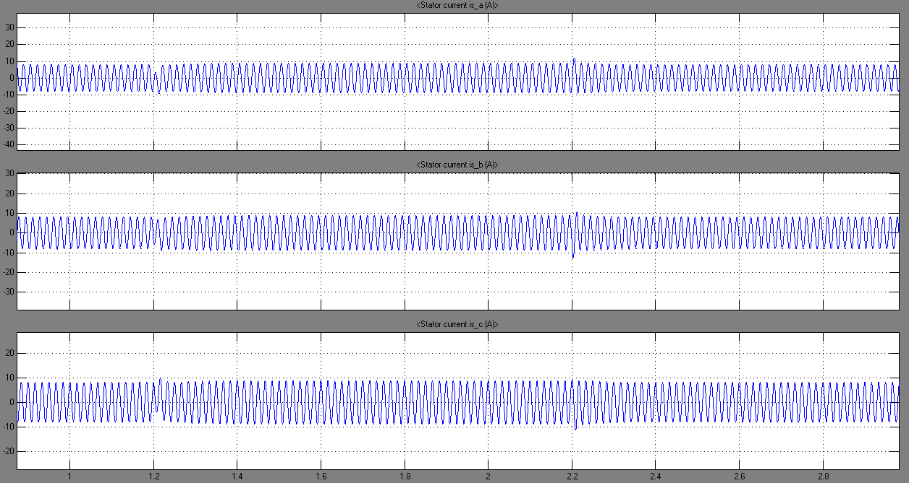

Figure 37: Stator Currents

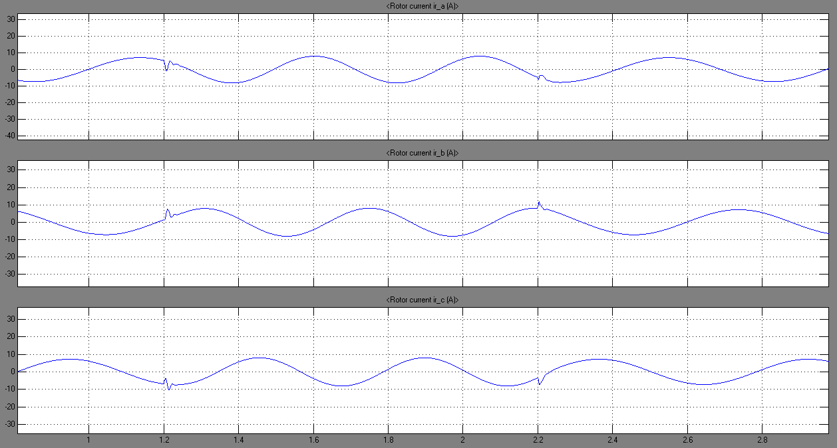

Figure 38: Rotor Currents

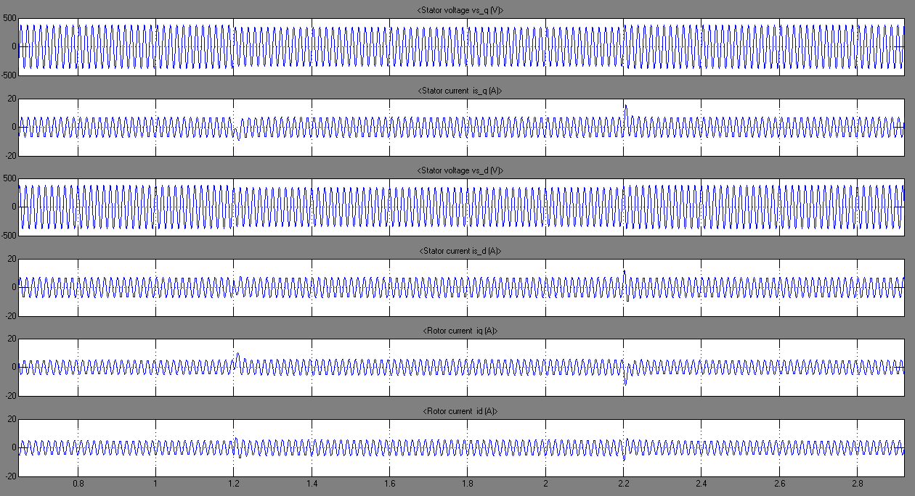

Figure 39: Rotor Currents, Stator Currents and voltages in stationary reference frame

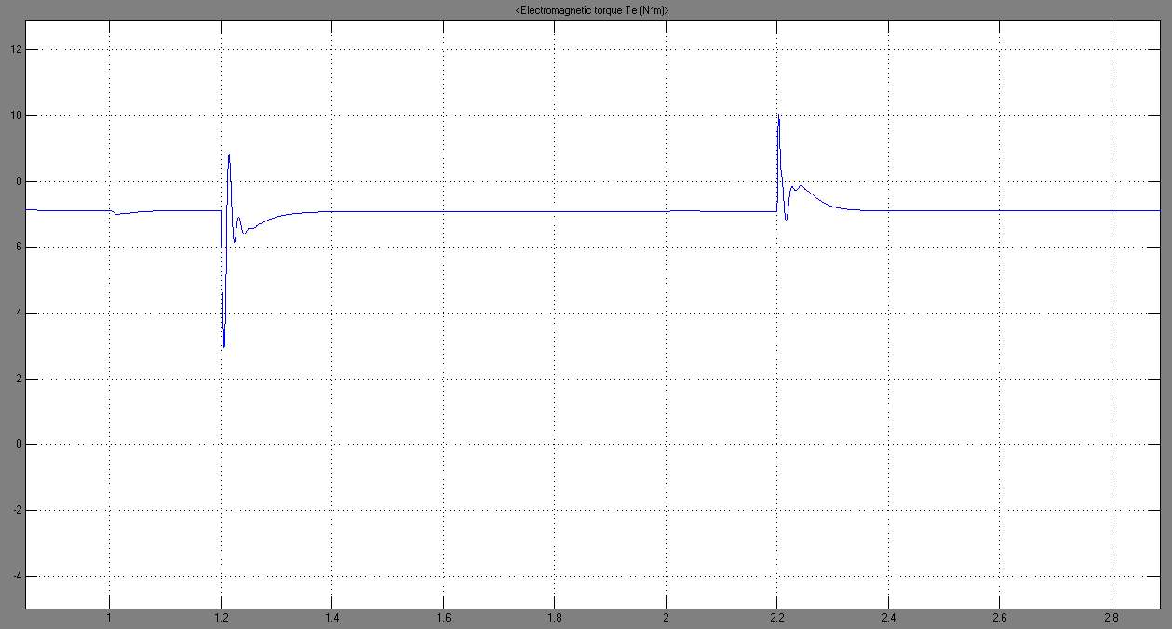

Figure 40: Electromagnetic Torque Te

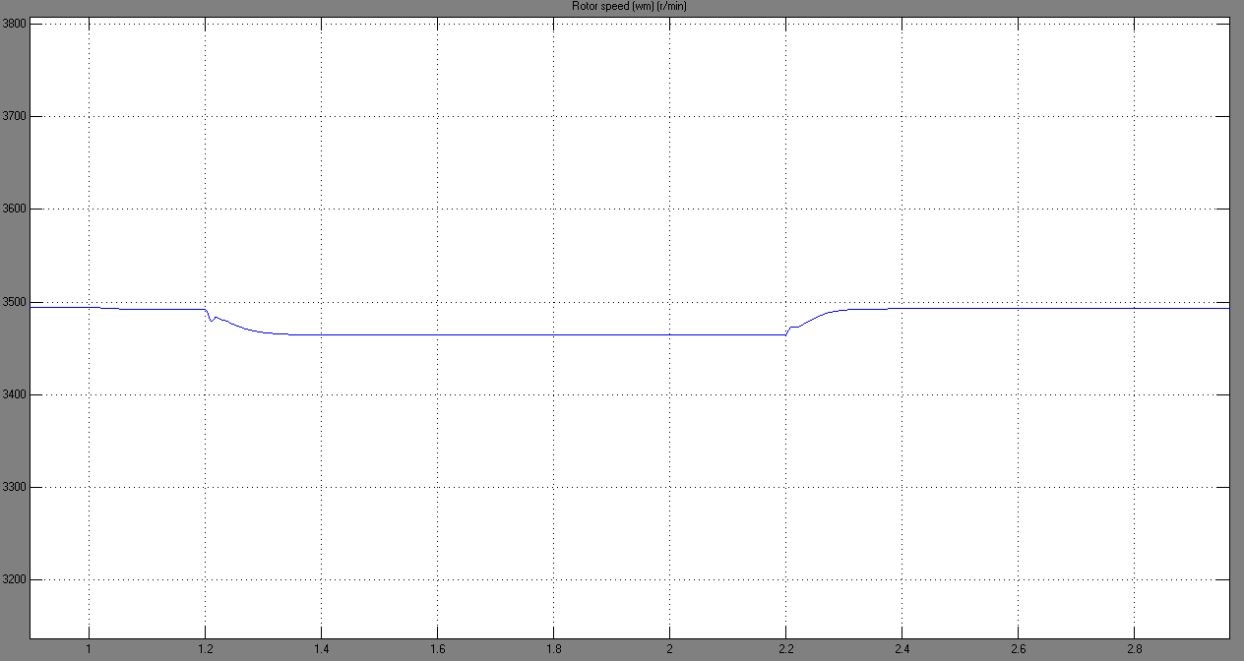

Figure 41: Rotor Speed



Figure 42: Torque versus Speed characteristics for different stator voltage magnitudes

# Synchronous Generator:

The synchronous machine is the principal means of converting energy from mechanical to electrical. Nearly all electric power is generated by synchronous machines drives either by hydroturbines or steam turbines or combustion engines. The rotor of a synchronous machine is equipped with a field winding and one or more short-circuited windings referred as damper windings. In general, the rotor windings have different electrical characteristics. Moreover, the rotor of a salient-pole synchronous machine is magnetically asymmetrical.

Due to the asymmetry and saliency, a change of variables offer no advantage in the case of the rotor variables. It is beneficial to define a change of variables or transformation for the voltages, currents and flux linkages of the stator circuits. This transformation replaces these stator variables with fictitious variables associated with circuits fixed in the rotor.

Reference frame theory is then used to establish the machine equations with stator variables transformed to a reference frame fixed in the rotor (Park’s equations).

## Theoretical background:

A two-pole three-phase salient-pole synchronous machine is shown in the figure below. The stator windings are identical a sinusoidally distributed with their magnetic axis displaced 120° from each other.

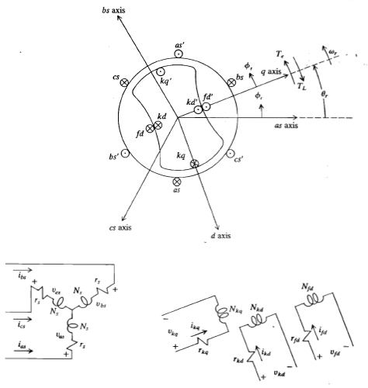

The voltages equations are given as following:  
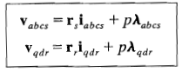 where 

The matrix rs and rs are 3x3 equal diagonal matrices corresponding to the stator and rotor winding resistances respectively.

The flux linkage equations may be written:  
 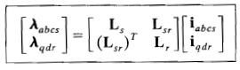 where  
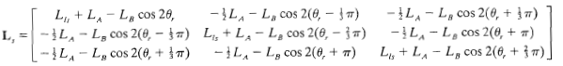

And   
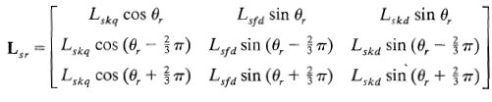  
where as 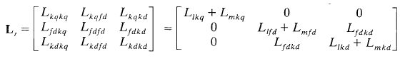

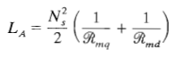 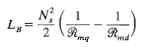

Considering the stator magnetizing inductances and the turn ratio by referring the rotor variables to windings with Ns turns (stator windings):  
    
the new set of equation became:  
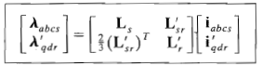

Where 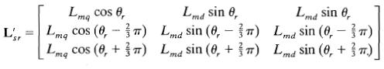  
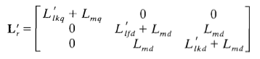  
the voltages equations become:   
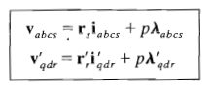& 

The electromagnetic torque positive for motor action and negative for generator action is given by:  
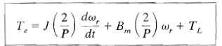

As we have mentioned before, we need to change the stator variables of the machine in a way to be fixed at the rotor reference frame. Since there are three stator variables ƒas, ƒbs & ƒcs it is necessary to replace them by three substitute variables to the rotor reference frame. It is a transformation from **abc** to **qdo**; the addition of the third fictitious variable ‘o’ which is the so called zero variable or zero quantity plays no role in the analysis in a balanced operation of a three-phase induction machine. And since we are working on a balance operation symmetrical induction machine this values is assumed to be a zero quantity.

In particular  
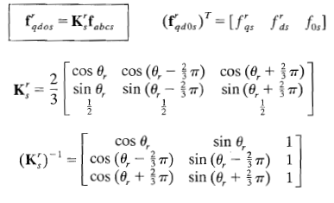

Where is the rotor displacement.

Hence the voltages equation in the rotor reference frame may be written in term of inductances:  
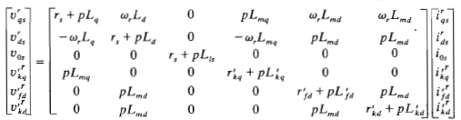

One property of the zero quantities can be noted from transformation; both ƒ0s and ƒ’0r are identically equal to zero if the three-phase sets are balanced (which is our case). A raised index is generally not associated with zero quantities since these variables are always in same frame of reference as the actual phase variables.

## Simulation part:

To investigate the three-phase synchronous generator we have used Simulink/Matlab and the SimPowerSystems toolbox where in the Machines library model of the synchronous generator is represented by the synchronous machine block:

We have investigated a 12 kVA, 460V , 60 Hz , 1800 rpm four-pole sychronous for various condition. The specifications of the selected generator are the following:

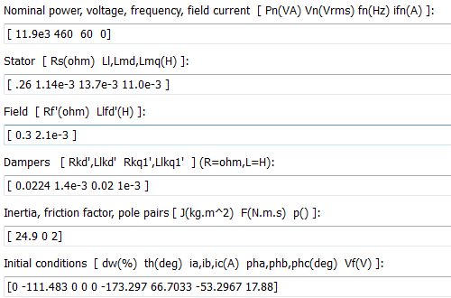

Since we are talking about generator operation, and right before starting the simulation, it would be important to notice that the electromagnetic and input torques are negative quantities. However, in order for the plots to be more comprehendible, they have been shown as positive quantities to adequately represent the torque increase (note also that the negative values of torques were also shown since they represent the actual quantities of interest).

### Synchronous Generator with a step change in the Torque:

### 

Figure 43: Simulink diagram for Synchronous Generator

During this scenario, the input torque was increased from 0 to 200 N.m at t = 2seconds. As we can observe, the stator voltages remained unchanged all along the simulation, while the stator currents, which were initially very small for TL = 0, started to increase once the torque was applied (TL = 200 N.m) at t = 2seconds, until reaching a steady state value (figure 44).

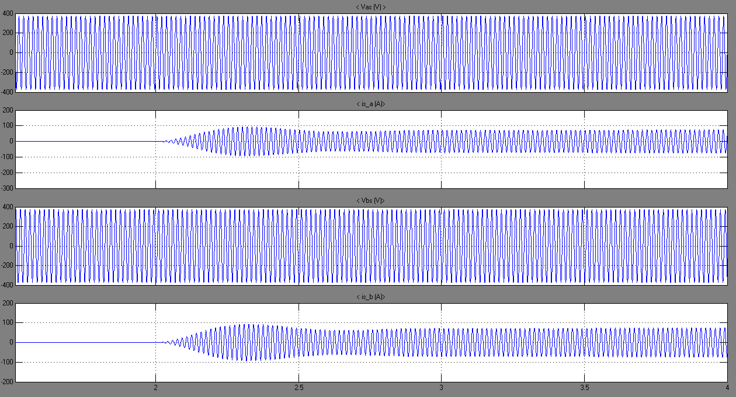

Figure 44: Stator Voltages and Currents

Figures 45 and 46 represent the variations seen in the electromagnetic torque, rotor speed, load angle and input torque. We can clearly observe that upon the application of the input torque (-TL), the machine immediately accelerates above synchronous speed as predicted by the expression:  and the rotor angle increases in accordance with

. The rotor continues to speed up until the accelerating torque on the rotor is zero. This occurs when Te is equal in magnitude to the input torque. As noted in figures 45 and 46, the speed increases to approximately 1809 rpm (electrical angular velocity). Even though the accelerating torque on the rotor is zero at this time, the rotor is still running above synchronous speed. Hence, δ will continue to increase and, consequently, Te will continue to decrease (increase negatively). This decrease in Te causes the rotor to decelerate and the speed of the rotor decreases toward synchronous speed. Note that at the first synchronous speed crossing of ωr after the torque disturbance, the rotor angle is approximately 30 electrical degrees and Te is approximately -300 N.m. The rotor speed decreases below synchronous speed, whereupon the integrand of  becomes negative and the rotor angle will begin to decrease. Damped oscillations of the rotor about synchronous speed continue until the new steady state operating point is attained.

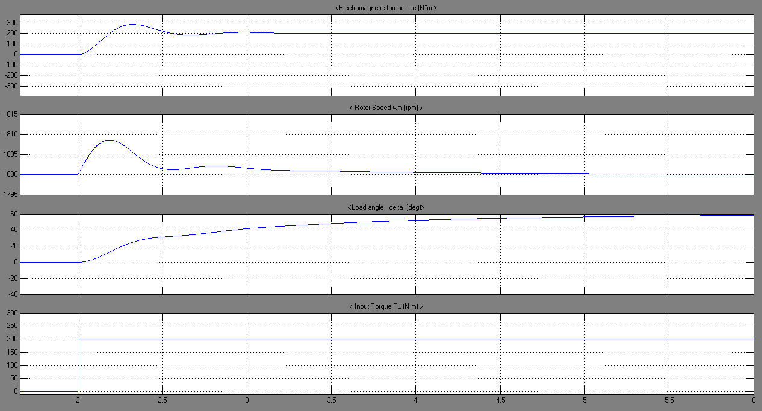

Figure 45: Torques, Speed and load angle

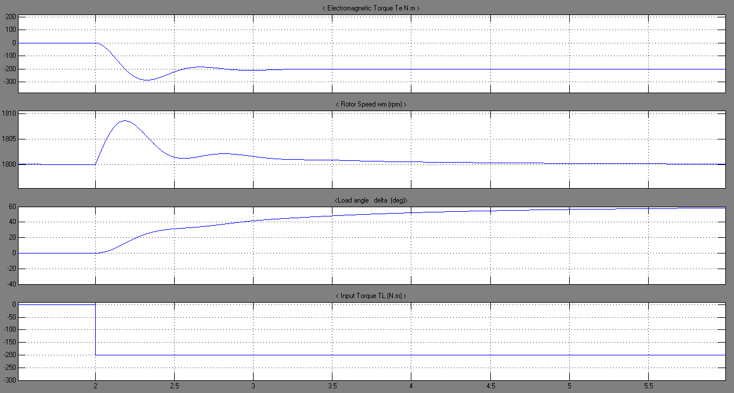

Figure 46: Torques, Speed and load angle

Figure 47 and 48 are repeats of figures 45 and 46 respectively, with the rotor reference frame variables plotted rather than the stator or machine’s variables. Also plotted is the field current . Although for this machine the field current changed only slightly owing to a change in flux linkage. In some cases, depending on the parameters and the type of disturbances, a considerable voltage may be induced in the field winding resulting a marked change in field current during the transient period.

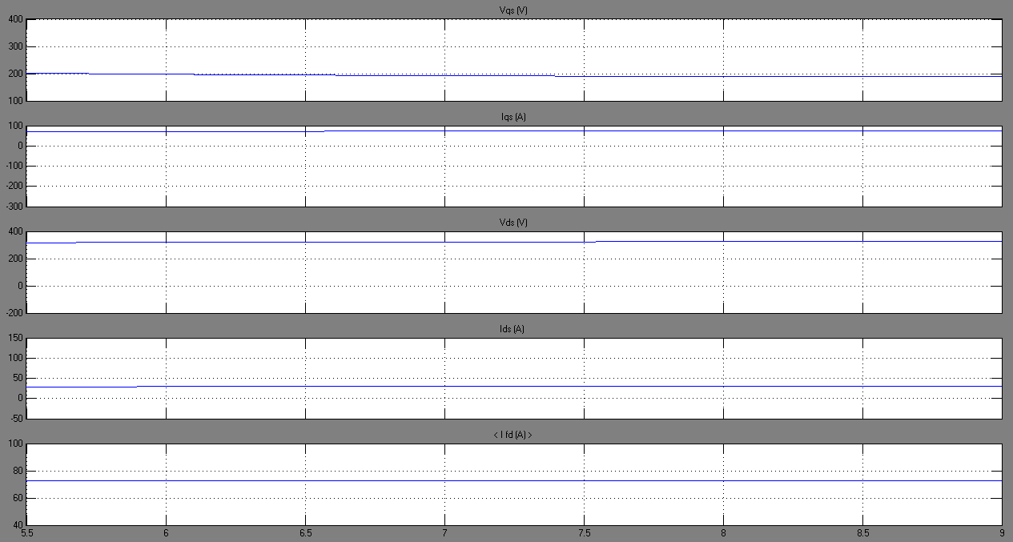

Figure 47: Voltages and Currents in the Rotor reference frame

Steady state representation for stator voltages and currents (figure 48), torques, speed and load angle (figures 49 and 50) are presented below. When steady-state operating point is reached, all quantities are stabilized at a certain constant value as shown here after.

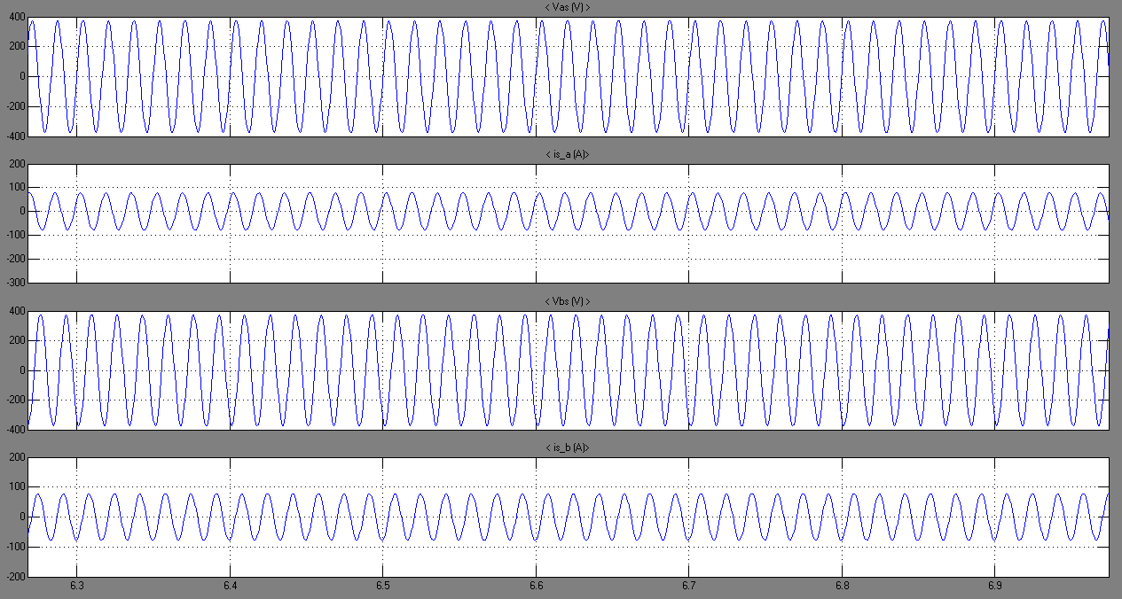

Figure 48: Stator Voltages and Currents at Steady state

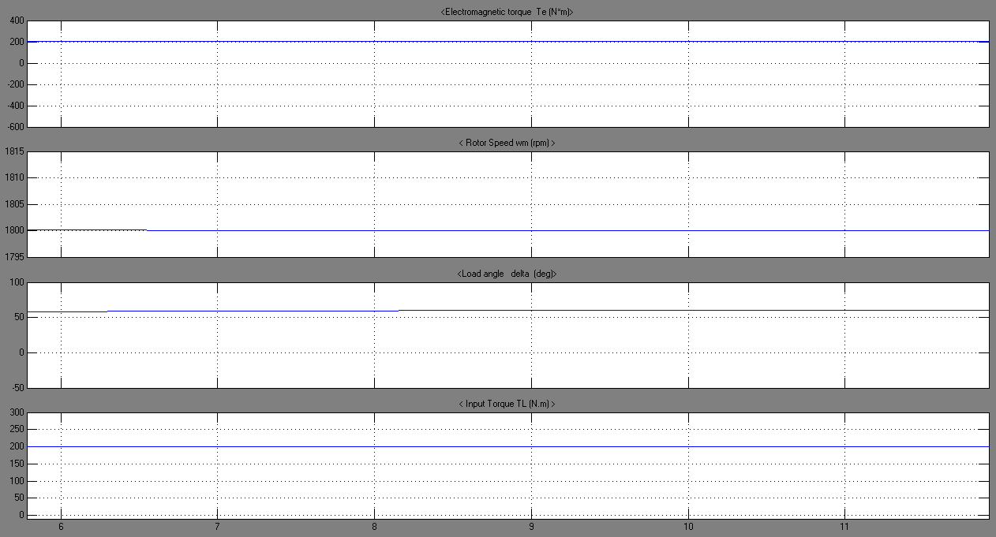

Figure 49: Torques, speed and load angle at steady state

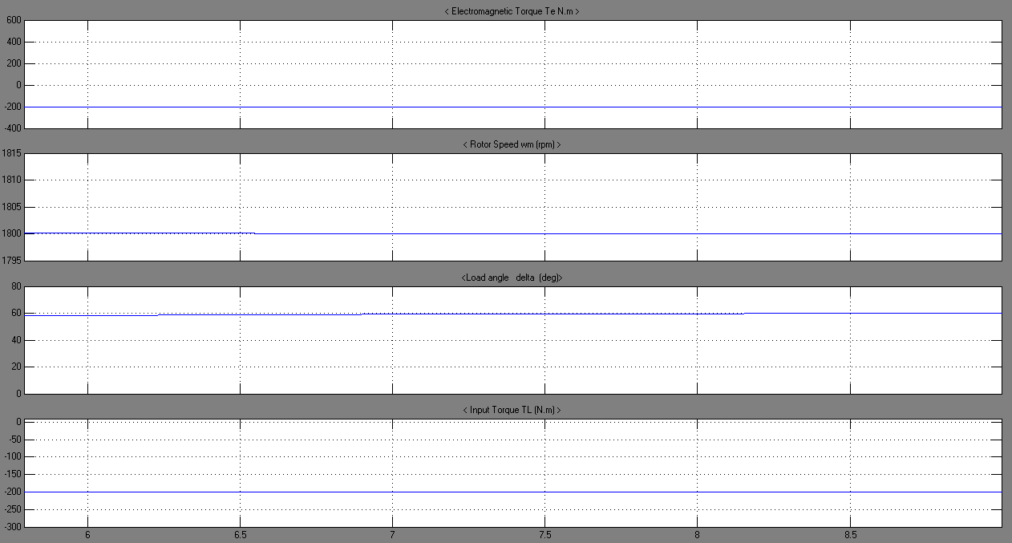

Figure 50: Torques, speed and load angle at steady state

The dynamic torque versus the rotor angle characteristics during and following the step change in input torque is shown in figure 51. It is interesting to note that it requires considerable time before the machine establishes steady-state operation at TL = -200 N.m. the steady state torque-angle curve which is also shown (in green) will pass through Te = 0 at δ ≈ 0 and TL = -200 N.m at δ = 60°; however, it is much different from Te versus δ during the transient period (curve in blue).



Figure 51: Torque versus rotor angle characteristics (dynamic and steady state operation)

### Step change in input torque (-50 N.m.):

During this scenario, the input torque was applied at t = 2seconds and has a smaller value than the one simulated in scenario A (TL = -50 N.m). All the variations confronted in scenario A was reproduced in this scenario but with smaller effects. As shown in figure 52, the stator voltages remained unchanged while the stator currents immediately increased once the input torque was applied; but the value attained by these currents was smaller than the ones attained with a higher input torque (-TL = 200 N.m). This is due to the fact that mechanical work, applied to the machine, is directly proportional to the electrical energy produced by this generator.

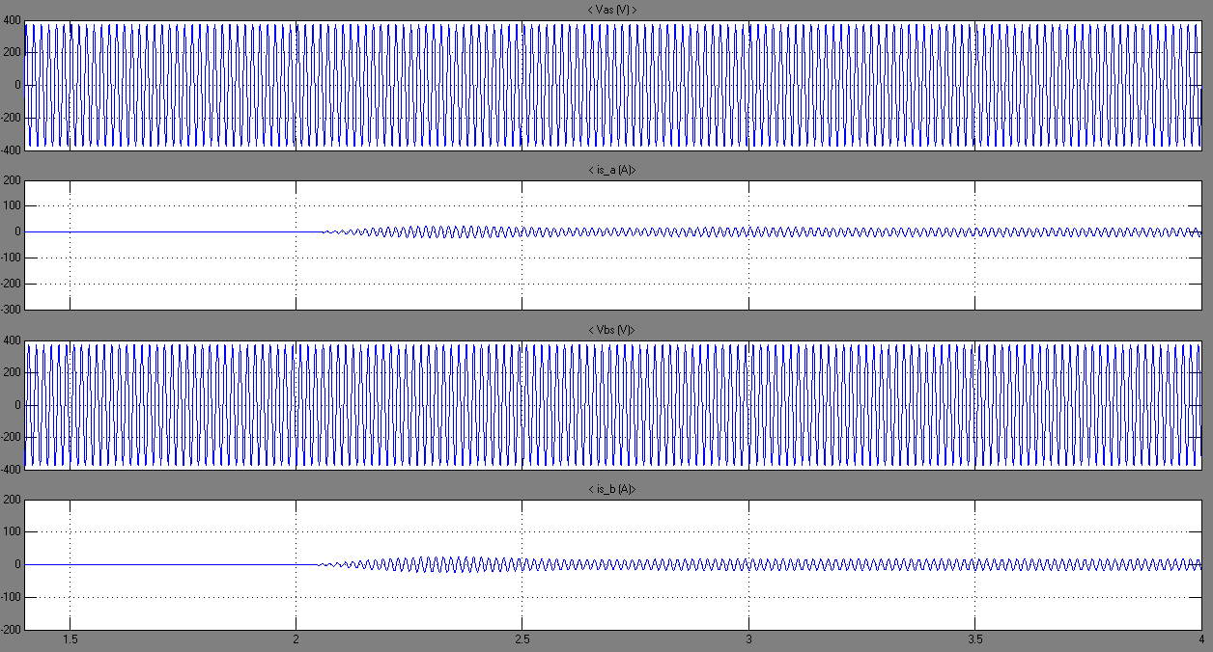

Figure 52: Stator Voltages and Currents

Similarly, figures 53 and 54 show the changes in electromagnetic torque, rotor speed, load angle and input torque. Since the input torque was smaller than the one encountered in the previous scenario, smaller increase in rotor speed (1802 vs 1809 rpm) occurs. Moreover, the electromagnetic torque which previously attained a value of -300 N.m has only reached -80 N.m in this case. As for the load angle which previously stabilized at δ = 60 electrical degrees, attained about 16 electrical degrees in this case (while noting the similar decrease in this load angle at around 14 electrical degrees corresponding to the first synchronous speed crossing of ωr after the torque disturbance with Te = -80 N.m).

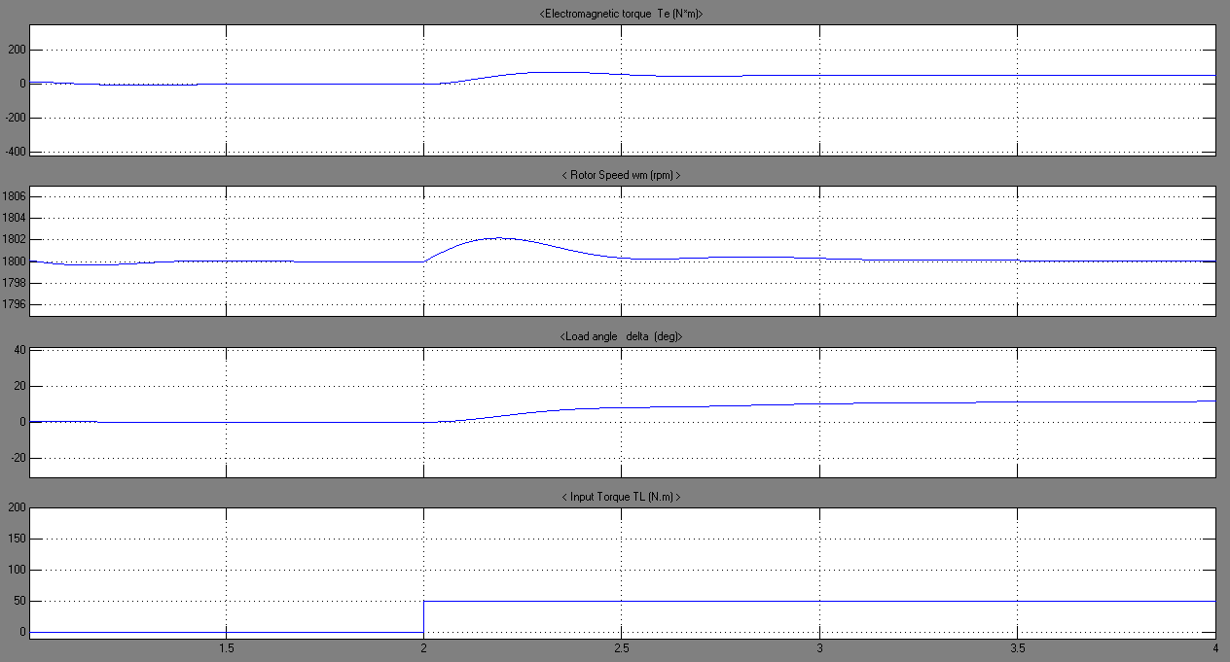

Figure 53: Torques, Speed and load angle

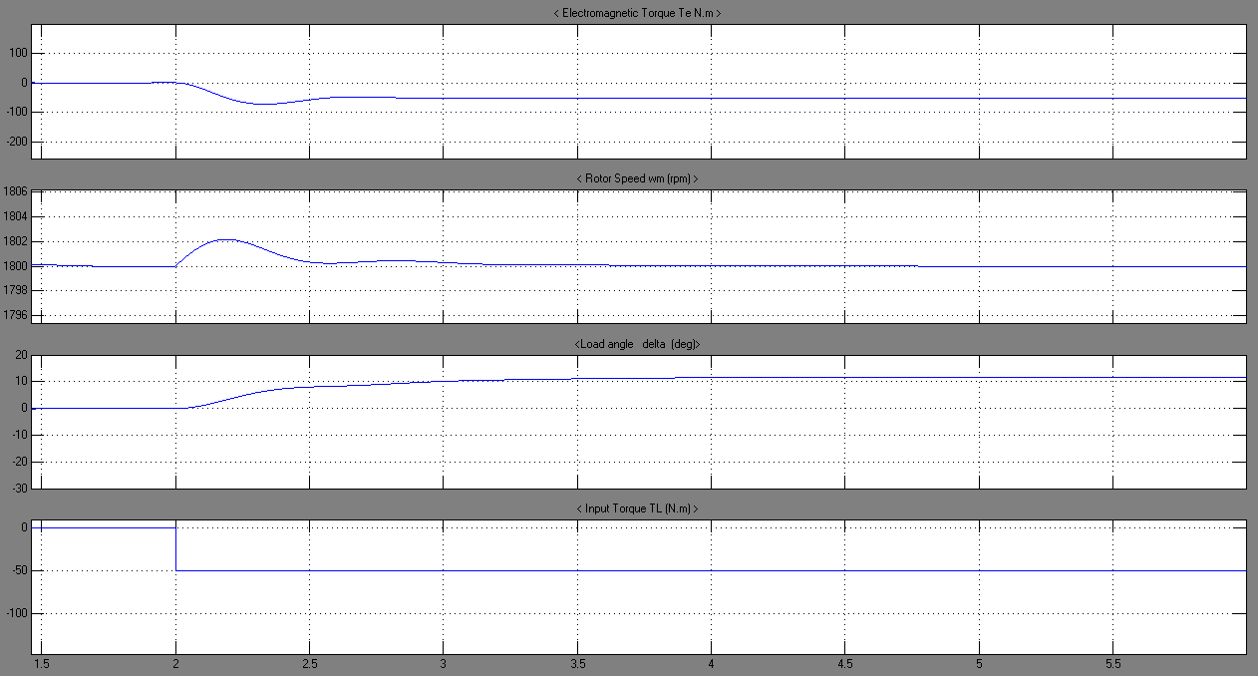

Figure 54: Torques, Speed and load angle

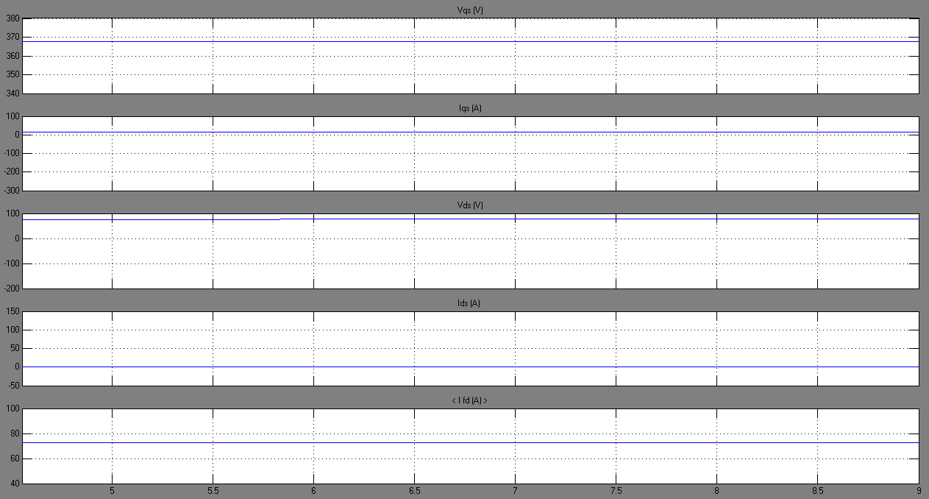

Figure 55: Torques, speed and load angle at steady state

### Various step changes in input torque:

In order to become more familiar with the effect of input torque changes, scenarios A and B were combined. That is, a variation of the torque from 0 to 200 N.m at t = 1.2 seconds, and, after enough time in order to reach steady state, a step down of the input torque from 200 to 50 N.m was observed at t = 3.2 seconds.

Figure 56 shows the uniform behavior of the stator voltages, which were not affected by the change in the input torque. As for the stator currents, a large increase was presented once the torque was stepped up, and reached steady state with a value of about 80 A. Accordingly, once the torque was stepped down to -50 N.m, the stator currents decreased to reach a steady state value of about 20 A. This clearly proves the direct proportionality existing between input torque and stator currents.

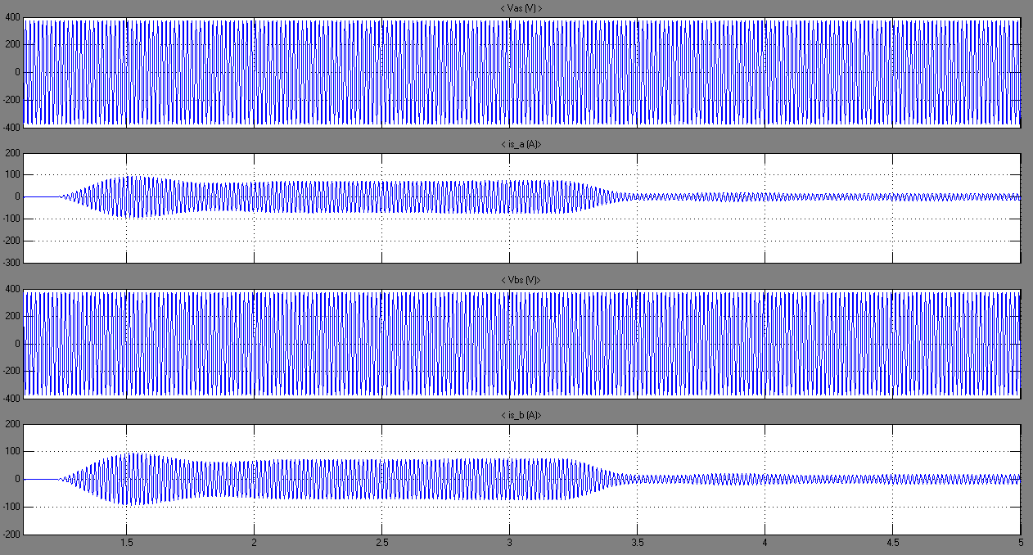

Figure 56: Stator Voltages and Currents

Figures 57 and 58 illustrate the dissimilar behavior of the machine’s characteristics for a step up and a step down in input torque. As we can notice, the electromagnetic torque increases (negatively) when input torque is stepped up and decreases when input torque is reduced. The values attained are similar to the ones obtained when each scenario was simulated alone. What is more, the rotor speed moves beyond synchronous speed when there’s a step up in the input torque, and goes below synchronous speed for a step decrease in input torque. Similarly, the load angle reaches 60 electrical degrees in the first step change and decreases to 16 electrical degrees during the second phase (note that these values are also similar to the ones found previously).

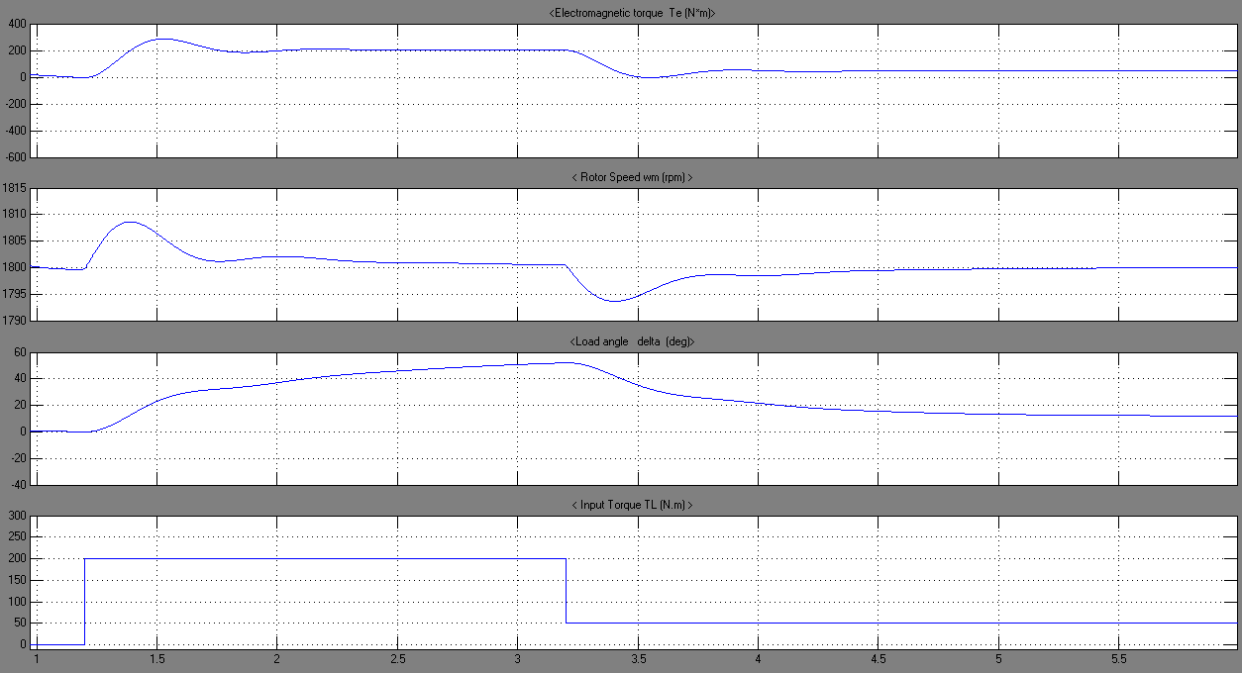

Figure 57: Torques, Speed and load angle

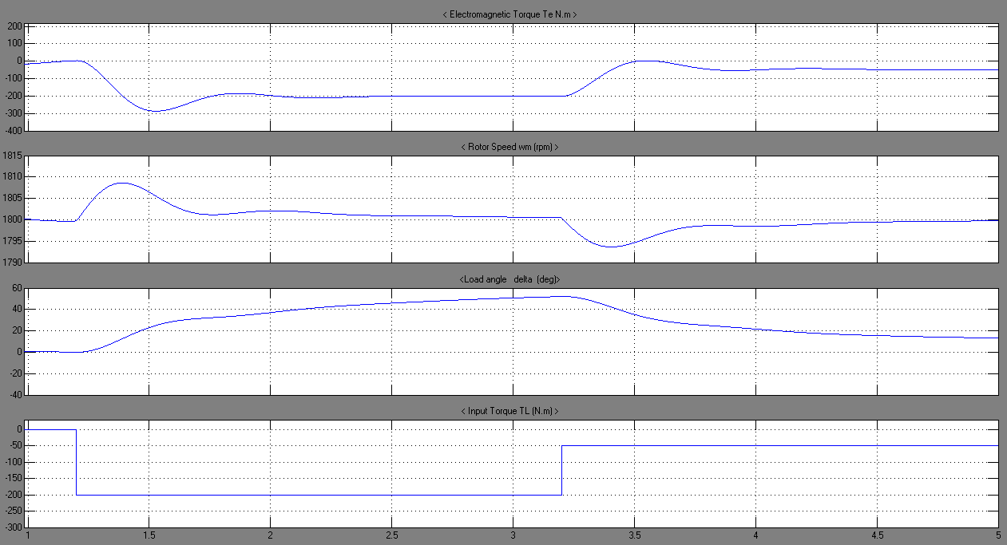

Figure 58: Torques, Speed and load angle

### Step change in rotor speed:



Figure 59: Simulink diagram for a step change in speed

In this scenario, a speed change was investigated. We considered the speed as the single input of the synchronous generator. The speed was decreased from 188.5 rad/s to 100 rad/s at  
t = 2 seconds.

Figure 60 represents the stator voltages and currents behavior during the change in rotor speed. We clearly notice an instantaneous decrease in voltage magnitudes and frequency once the speed is stepped down (t = 2s). Similarly, the currents amplitudes were decreased and there frequencies reduced.

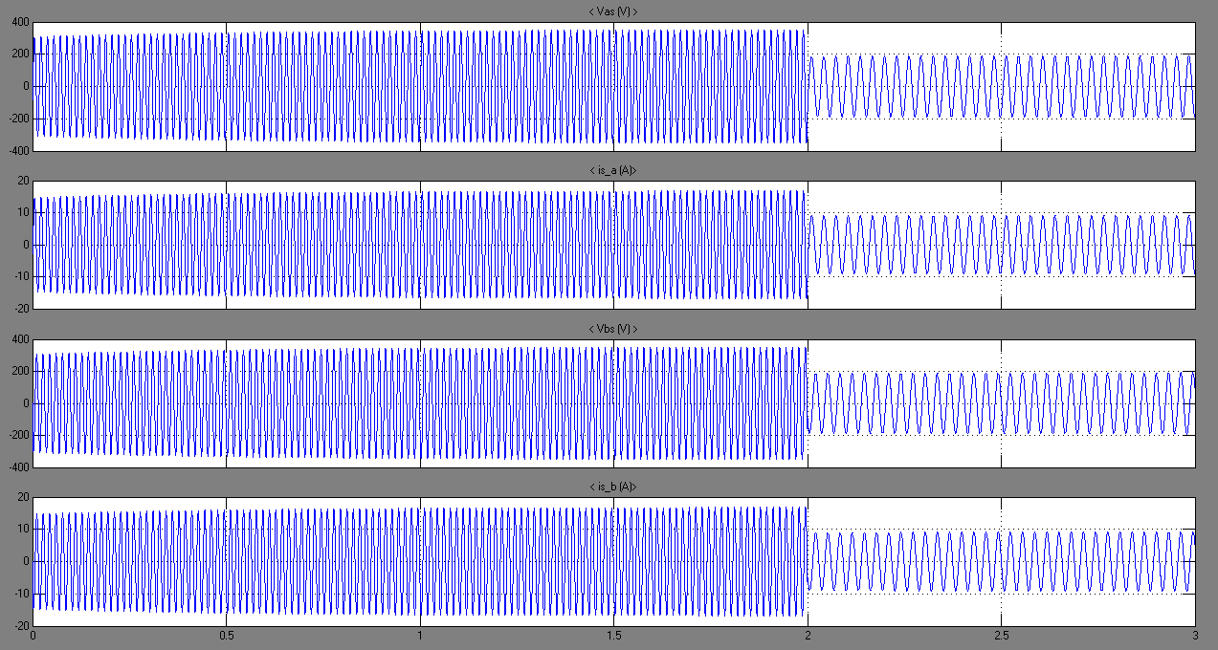

Figure 60: Stator Voltages and Currents

As for the electromagnetic torque and load angles (shown in figures 61 and 62), they were also subject to change once the speed was decreased. Since the electromagnetic torque is directly related to rotor speed, a reduction in speed will yield a drop in the torque. What is more, since the speed deviated from the synchronous one, the angle will decrease proportionally, until reaching steady state at around 7 electrical degrees.

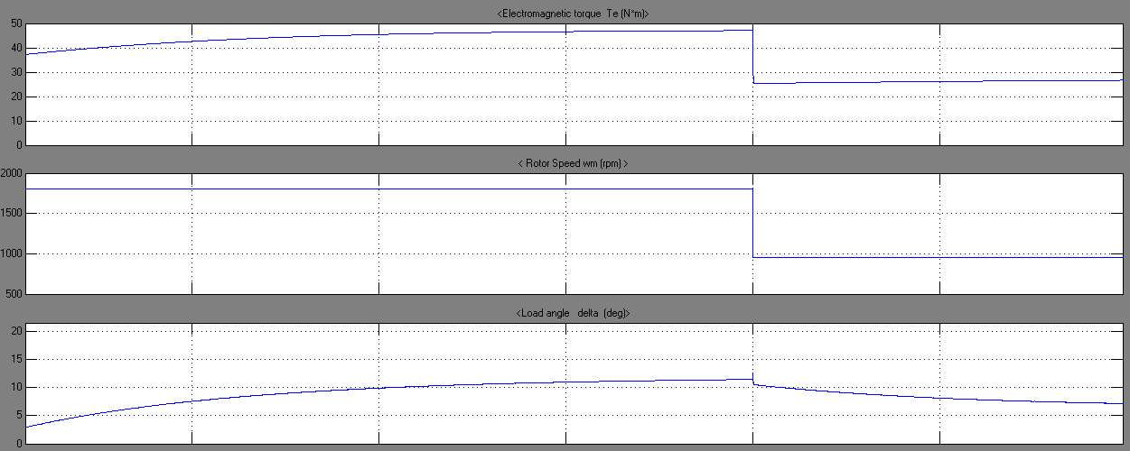

Figure 61: Electromagnetic Torque, Speed and load angle

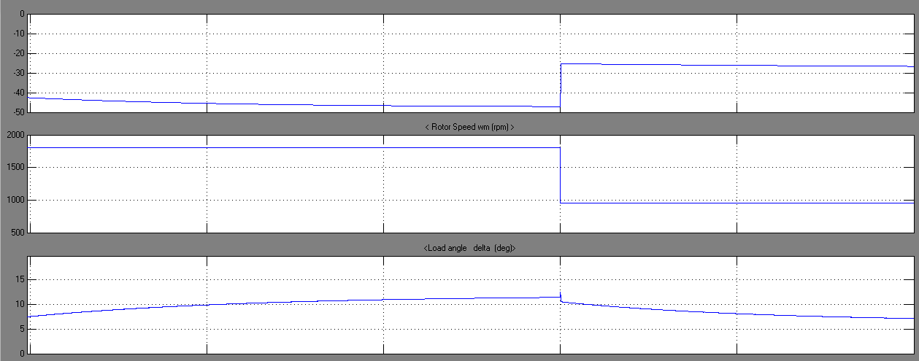

Figure 62: Electromagnetic Torque, Speed and load angle

When considering currents and voltages which are referred to the rotor reference frame, a similar behavior is illustrated in figure 63. These two machine’s characteristics were also proportionally affected by the speed reduction; that is, a instantaneous decrease in the voltages and currents are observed, until attainment of steady state operation point. As for the field current, applied on the rotor, it is subject to an instantaneous decrease once the speed is dropped (owing to a change in the flux linkage) and it directly returns to its initial position.

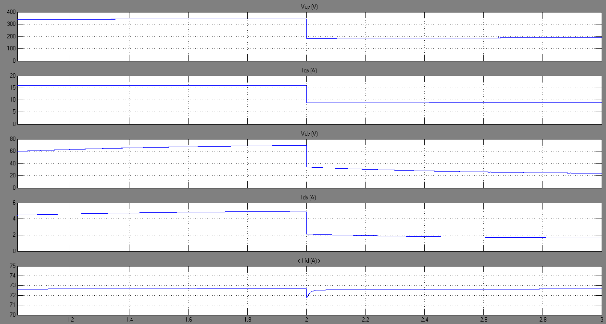

Figure 63: Currents and voltages in Rotor reference frame

### A change in the electrical load:



Figure 64: Simulink diagram for a change in load

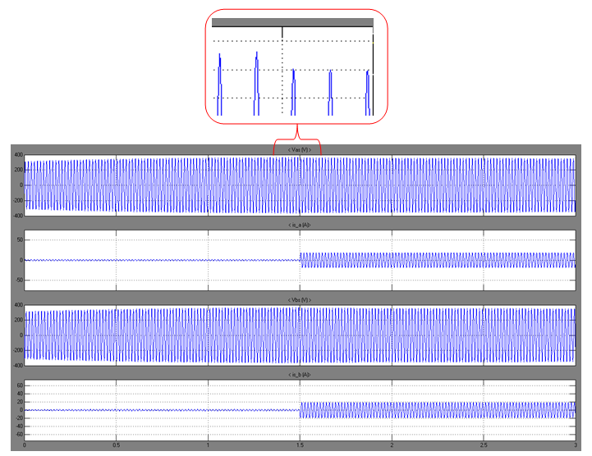

Figure 65: Stator Voltages and Currents

In this scenario, a change in load was interpreted. Initially, the electrical load on the generator was P = 1000 W and Q = 100 Var, at t = 1.5 seconds, additional load was added having 10000W and 1000 Var whereas the speed was maintained constant all along the simulation since it is the single input of the machine.

Figure 65 shows that due to an increase in the load, Stator voltages slightly dropped, whereas the currents instantaneously increased to satisfy the load requirements. Figures 66 and 67 represent the electromagnetic torque, the rotor speed and the load angle. Since the speed is an input to the system, it remains constant all along the scenario as observed in the figures. As for the electromagnetic torque, it increases (negatively) once the load was stepped up to satisfy the higher load demand. As for the load angle it increases once the load, thus the electromagnetic torque is increased to reach a new steady state operating point.

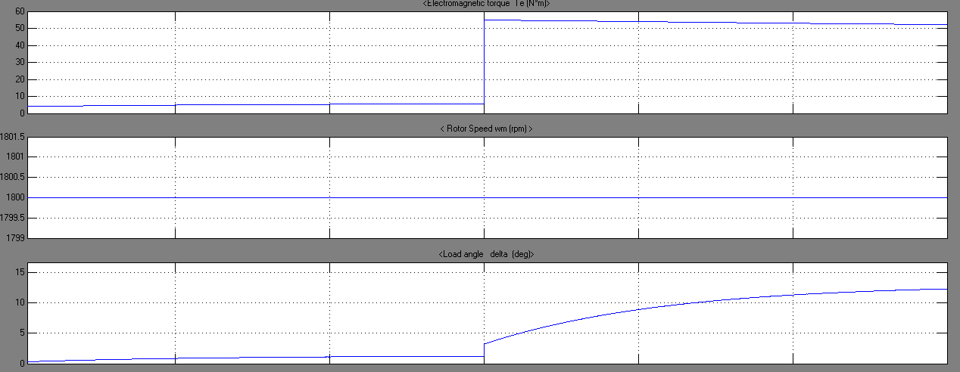

Figure 66: Torque, Speed and load angle

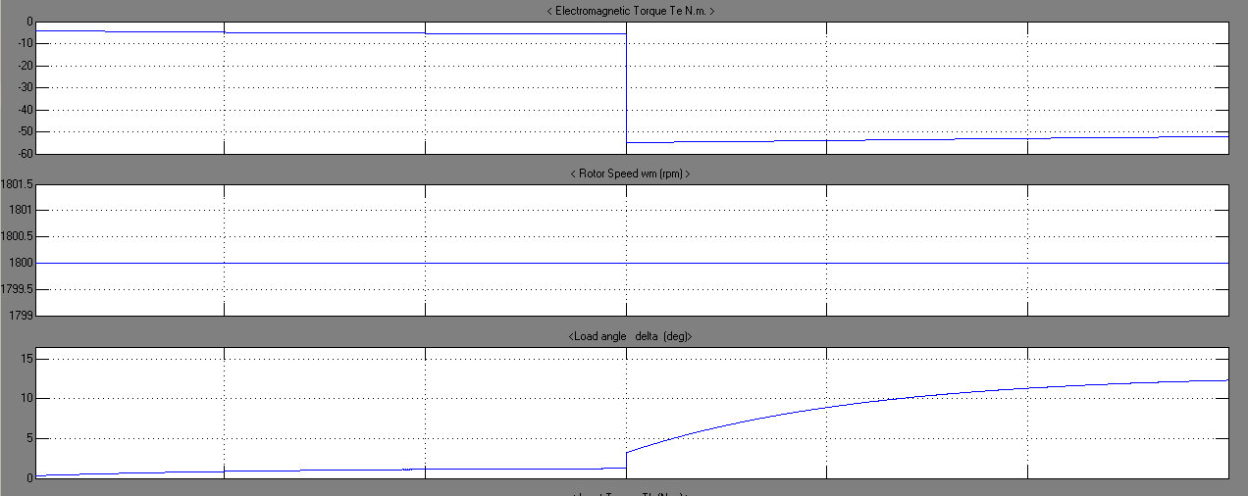

Figure 67: Torque, Speed and load angle

### Change in the field characteristics:

In this scenario, a change in the field characteristics was applied in order to observe its effect on the dynamic behavior of the synchronous generator. Since the field characteristics (impedances) are directly related to the field voltage a 5% increase of the field voltage was performed. We note, that initially the field voltage has a value of 21.8163 V as given by   
power gui.

Figure 68 represents the stator voltages and currents during steady state operating point. The stator currents slightly decrease whereas the voltages remain unchanged.

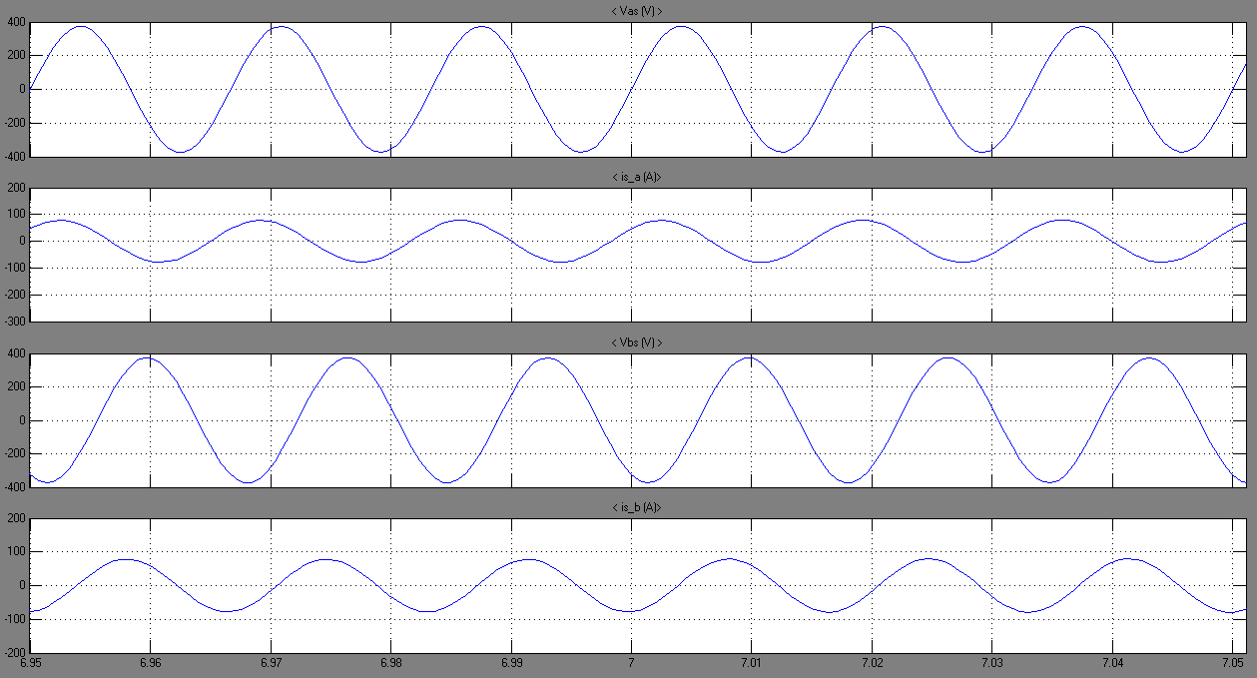

Figure 68: Stator Voltages and Currents

Figure 69 and 70 illustrate the electromechanical torque, rotor speed, load angle and input torque. The rotor slows down; the speed will deviate from synchronous speed. Hence, the load angle is instantaneously decreased. As for the electromagnetic torque, it fluctuates once the field voltage is changed and oscillation will dampen until reaching a steady state point.

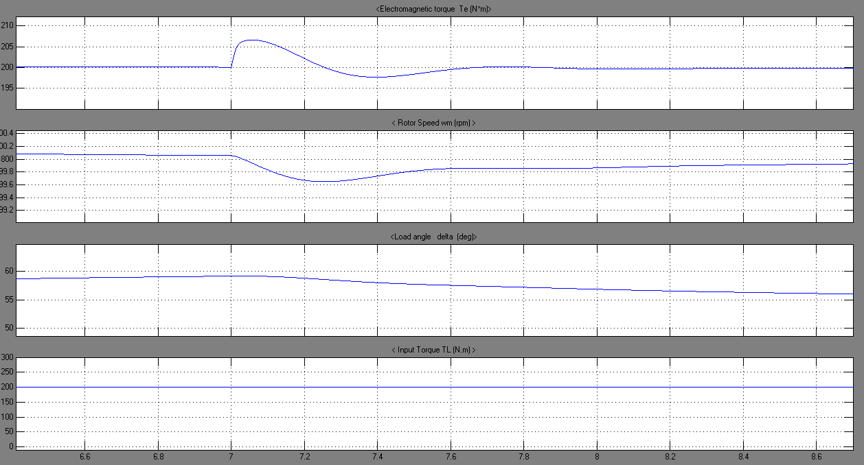

Figure 69: Torques, speed and load angle

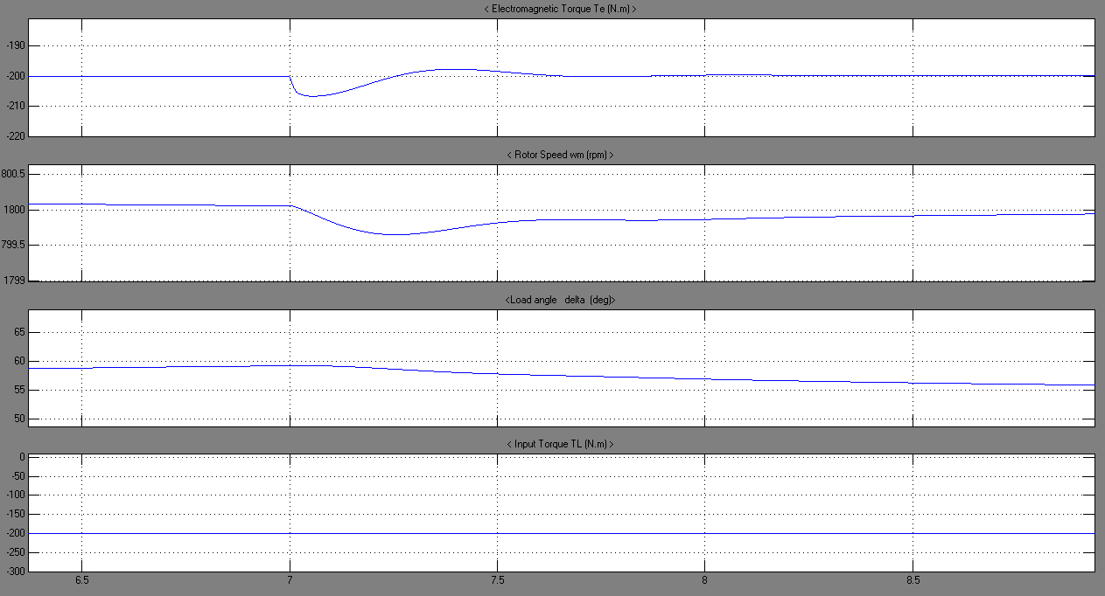

Figure 70: Torques, speed and load angle

Figure 71 shows the voltages and currents in the rotor reference frame. It illustrates the variation of the field voltage on the current and voltages quantities. Obviously, as expected the field current increases instantaneously when the field voltage is stepped up. As for the voltages and currents, they were also affected by this variation.

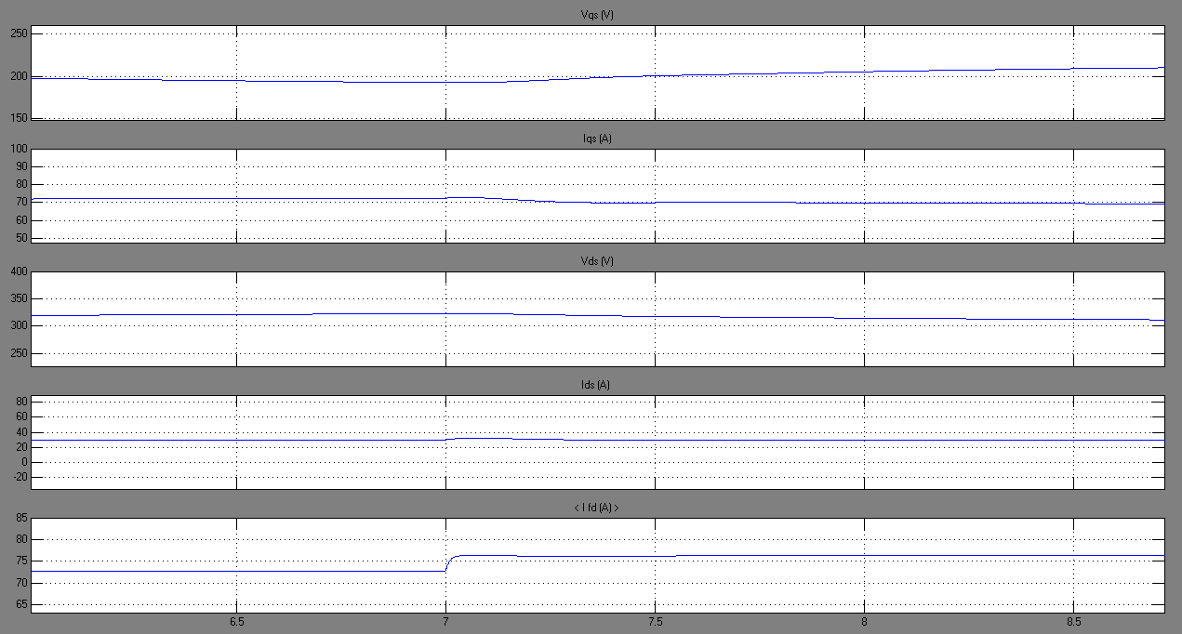

Figure 71: Voltages and Currents in rotor reference frame

In order to clearly observe the effect of the variation of the field voltage on the characteristics of the synchronous generator, an exaggeration of the voltage field increase was applied (20% increase). The plots shown below represent similar effect in an amplified manner. The decrease in the stator current is well represented in figure 72 . As for the electromagnetic torque, a higher overshoot is observed after which, steady state stability was attained. Concerning the rotor speed a higher overshoot (negative) was realized and larger deviation from synchronous speed was confronted. Similarly, the load angle was subject to a larger decrease when compared to a 5% increase in field voltage.

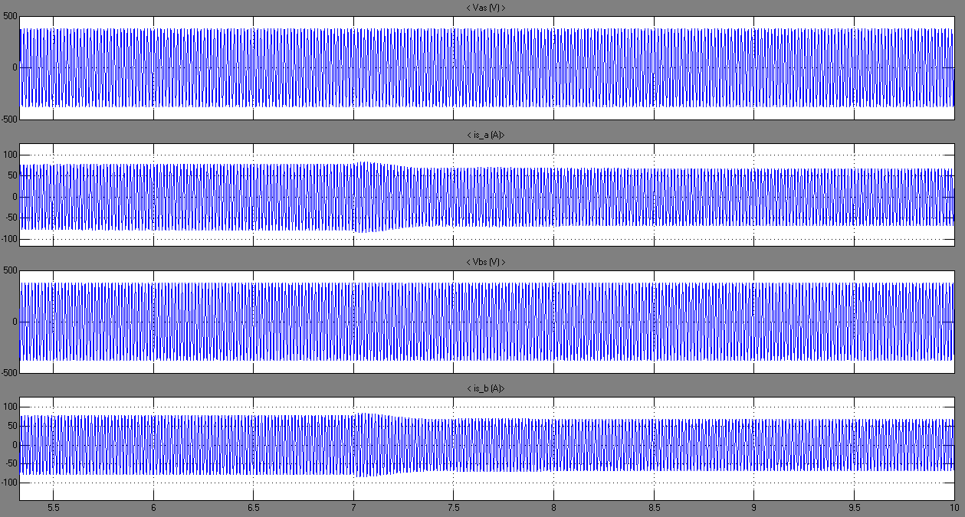

Figure 72: Stator Voltages and Currents

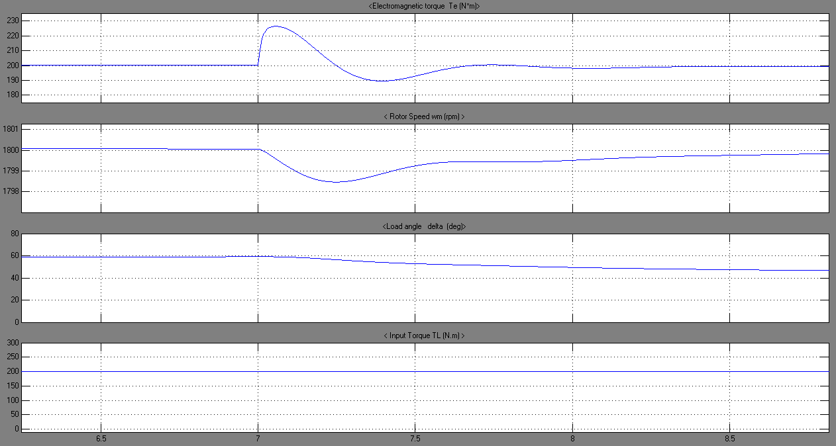

Figure 73: Torques, speed and load angle

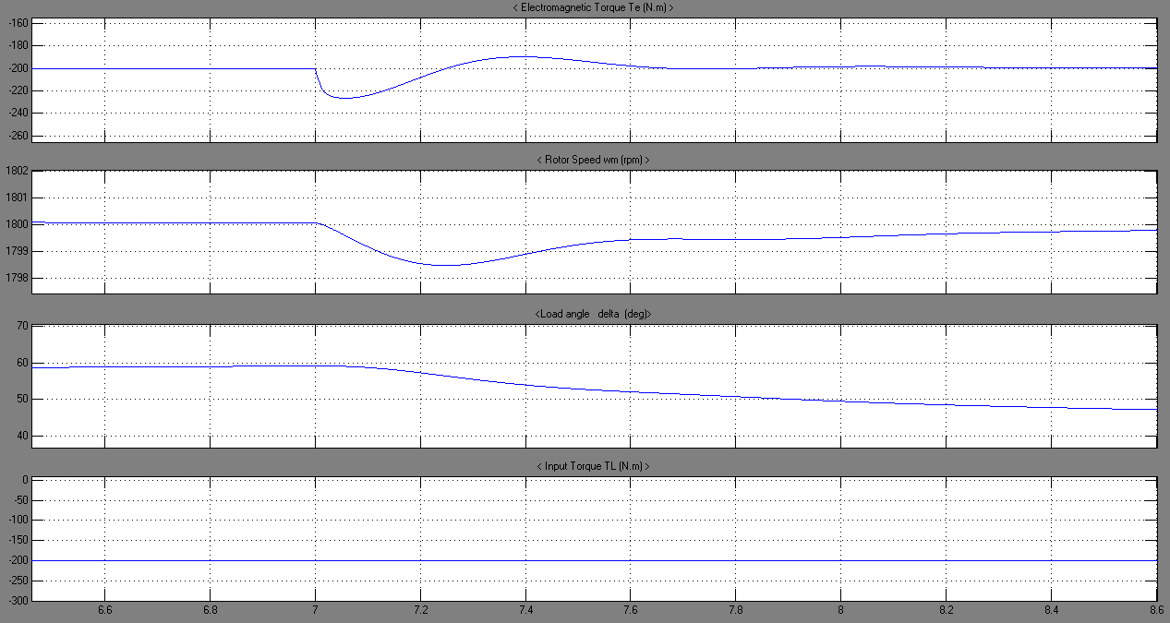

Figure 74: Torques, speed and load angle

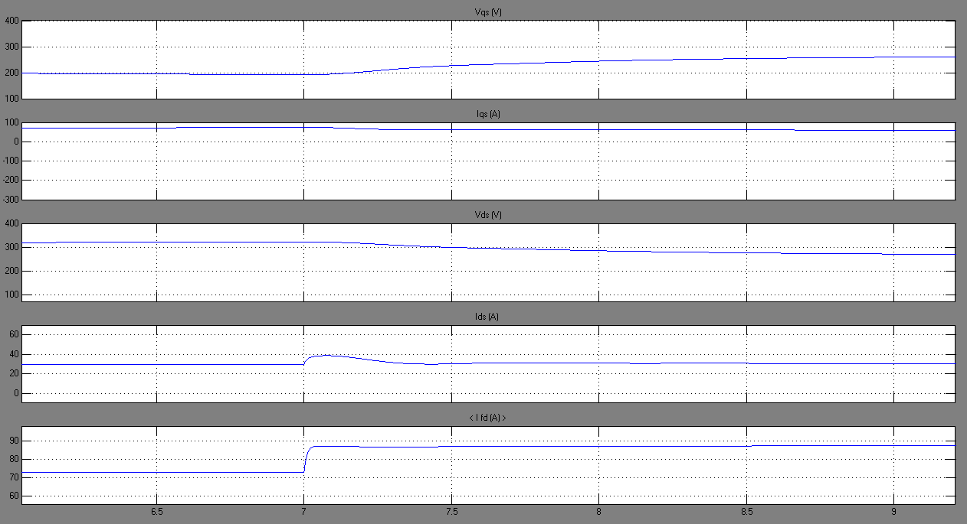

Figure 75: Voltages and Currents in rotor reference frame

Concerning the field current, it is obvious that an increment expected due to the increment in field voltage.

# Combined Model: Synchronous Generator feeding Induction Motor:



Figure 76: Simulink diagram for the combined Generator-Motor model

### Synchronous Generator feeding induction motor for a Torque increase:

In order to view the behavior of the combined system, i.e. a synchronous generator feeding an induction motor, we have simulated the previously shown Simulink Block diagram under load torque variation on the motor side. At t = 3 seconds, and after stability of the generator has been reached, an increase in the load torque was performed (from 0 to 20 N.m) on the induction motor side. This step increase is shown in figure 77.

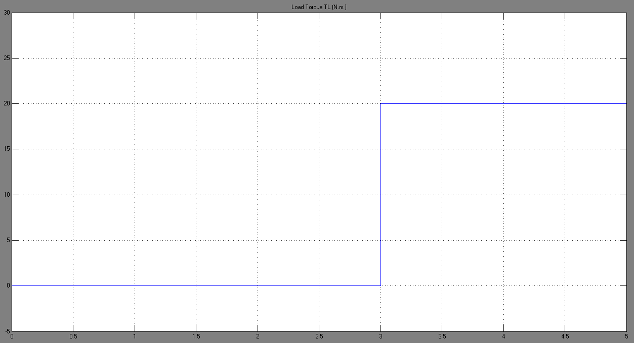

Figure 77: Load Torque TL

Figure 78 illustrates the behavior of the stator currents viewed from the motor side once the load torque is applied. We can notice that at t = 3 seconds, an instantaneous increase in the stator currents has occurred owing to the increase in the torque load. As for figure 79, rotor currents have also been subject to an instantaneous increase once the torque load was applied.

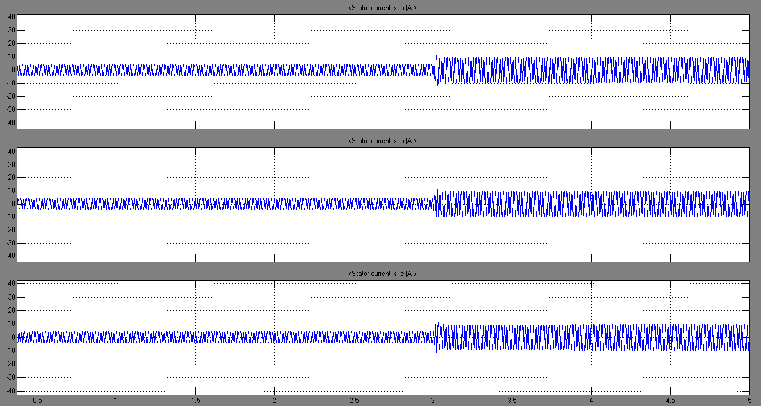

Figure 78: Stator Currents (motor side)

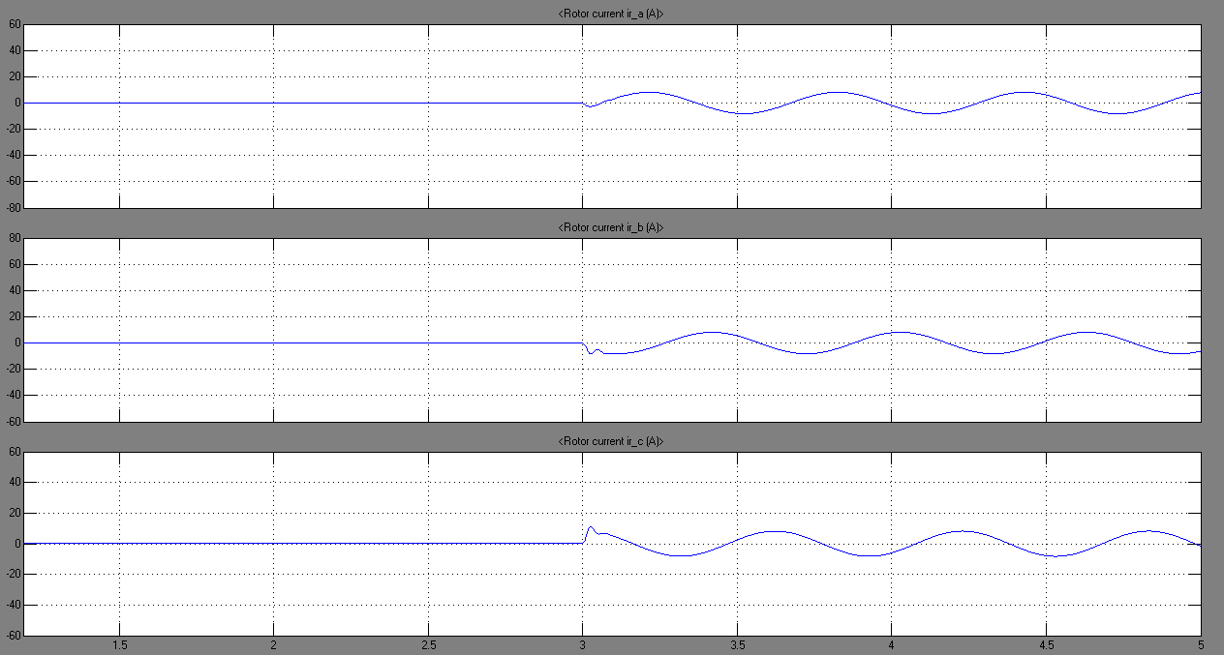

Figure 79: Rotor Currents (motor side)

Concerning the electromagnetic torque and the rotor speed on the induction machine’s side, they have acted in opposite manners (figures 80 and 81). The electromagnetic torque directly increased whereas the speed decreased, once the torque load was applied. This is certainly due to the torque and speed relationship; as we have increased the torque load from 0 to 20 N.m, the electromagnetic torque also increased with a value slightly higher than 20 N.m; so in order for the equation to be consistent, the speed has decreased in order to compensate for the losses which are due to friction and windage. Another justification would be: since the frequency of the rotor currents has been changed, the rotor speed will be directly affected.

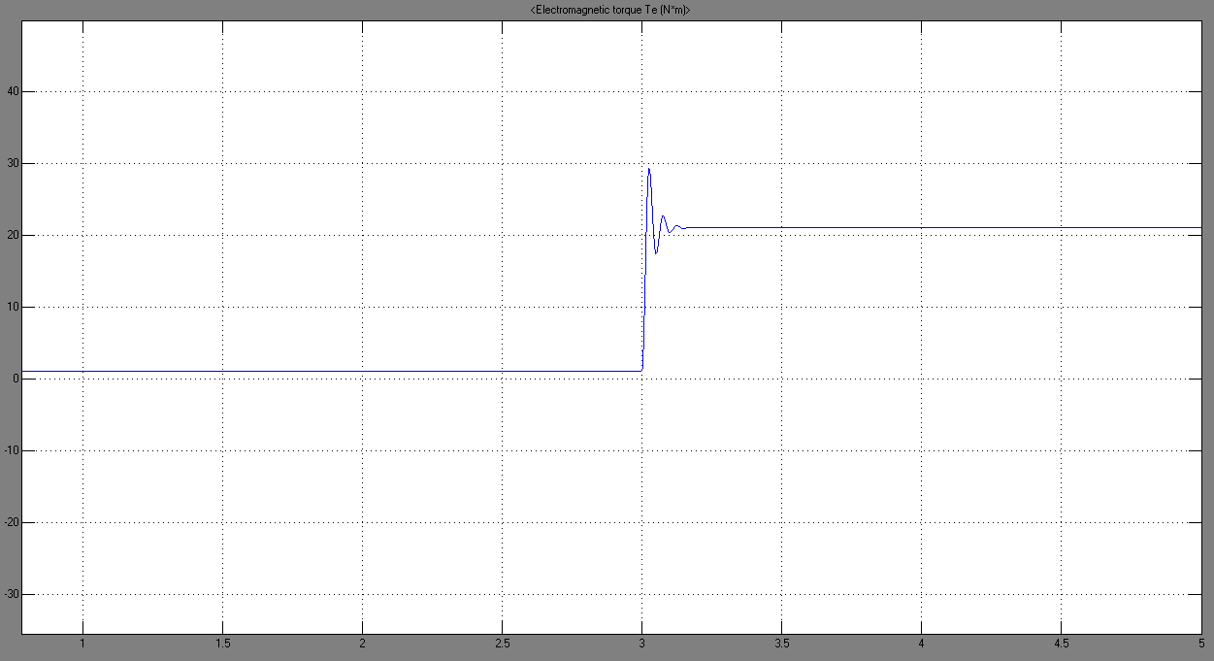

Figure 80: Electromagnetic Torque Te (motor side)

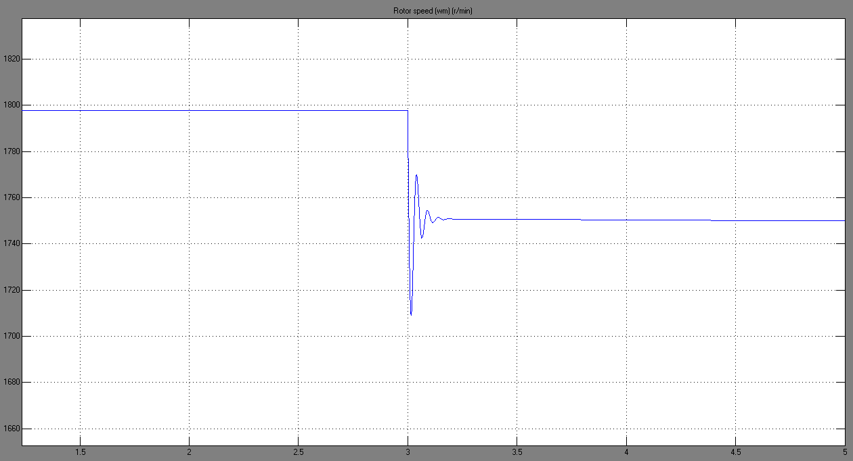

Figure 81: Rotor Speed (r/min)

In what concerns the stator voltages, which were applied to both, the stator of the generator and the stator of the motor, they have been shown in figure 82 with an emphasis on the variation at the time the torque load was applied. We can clearly notice, a slight decrease in these voltages, which is due to nothing but the load increase. Since this behavior is frequently encountered in many applications where a generator is feeding a motor (or a load), voltage regulation devices would be of great importance in order to maintain stability. However, since in our application the voltage drop has not exceeded its limit (±5%), regulators were not introduced.

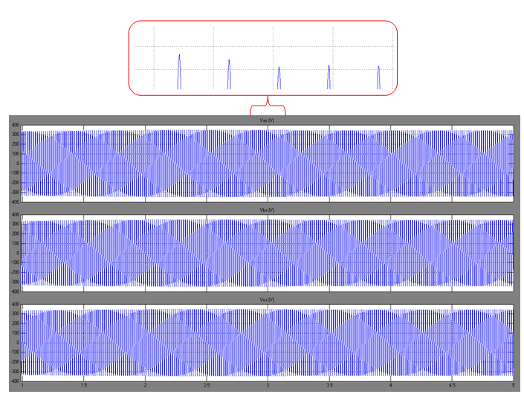

Figure 82: Stator Voltages

Figure 83 illustrates the stator currents delivered by the generator. These currents supply in addition to the induction motor, a constant load having a value of P = 1000W and Q = 100 var: . Before the application of the torque load, the currents delivered by the generator were mainly supplying the load; this can be noticed when comparing figure 83 and figure 78. Once the load torque is applied on the motor shaft, this induction machine will absorb more current which will be delivered from the generator. A comparison of the increase in the currents in the two machines (which is equal in quantity) at t = 3 seconds would be of interest.

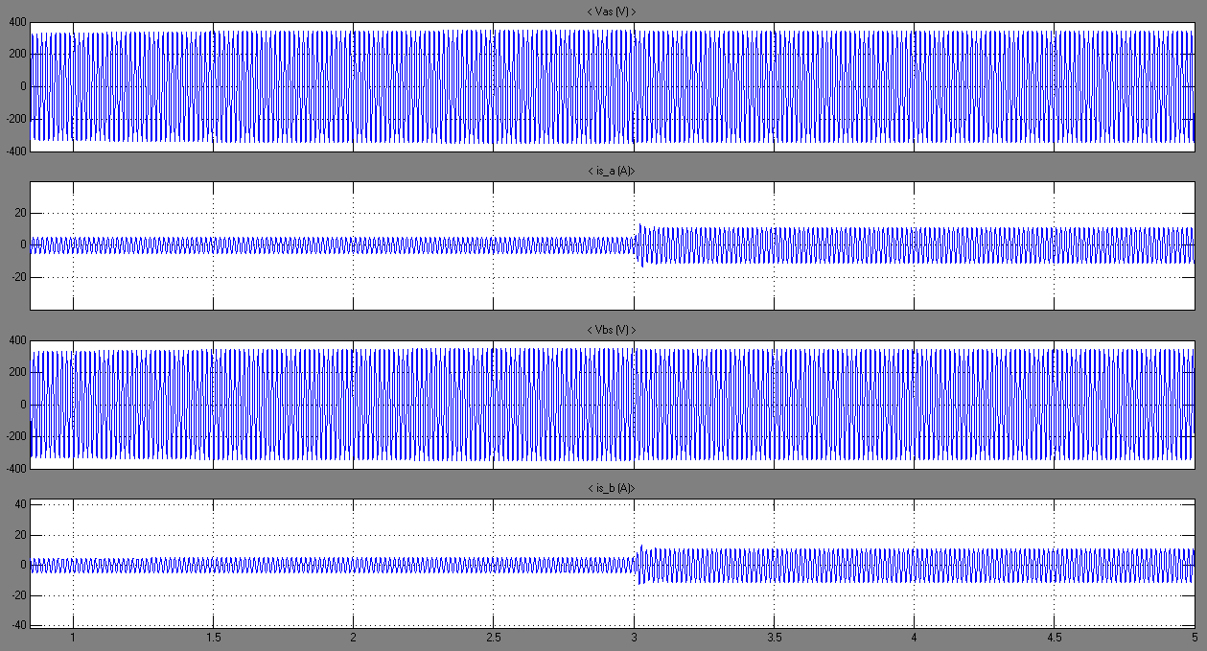

Figure 83: Generator Stator Voltages and Currents

As for the generator’s electromagnetic torque, speed and load angle, they are represented in figure 84. An increment in the electromagnetic torque was expected once the generator was to be more loaded (addition of TL at t = 3 seconds on the motor shaft). As for the rotor speed, we maintained it constant as it is the single input to the generator. In what concerns, the load angle once the load was increased, δ will directly increase and finally reach a steady state operating point.

Figure 85 presents the active and reactive power P and Q respectively absorbed by the induction motor. These powers are subject to change once the torque load was increased at t = 3 seconds. As its name indicates, an induction motor will absorb reactive power even before an application of torque load. As for the active power P, an obvious increase to 1400 W has occurred at t = 3 seconds once the torque was applied.

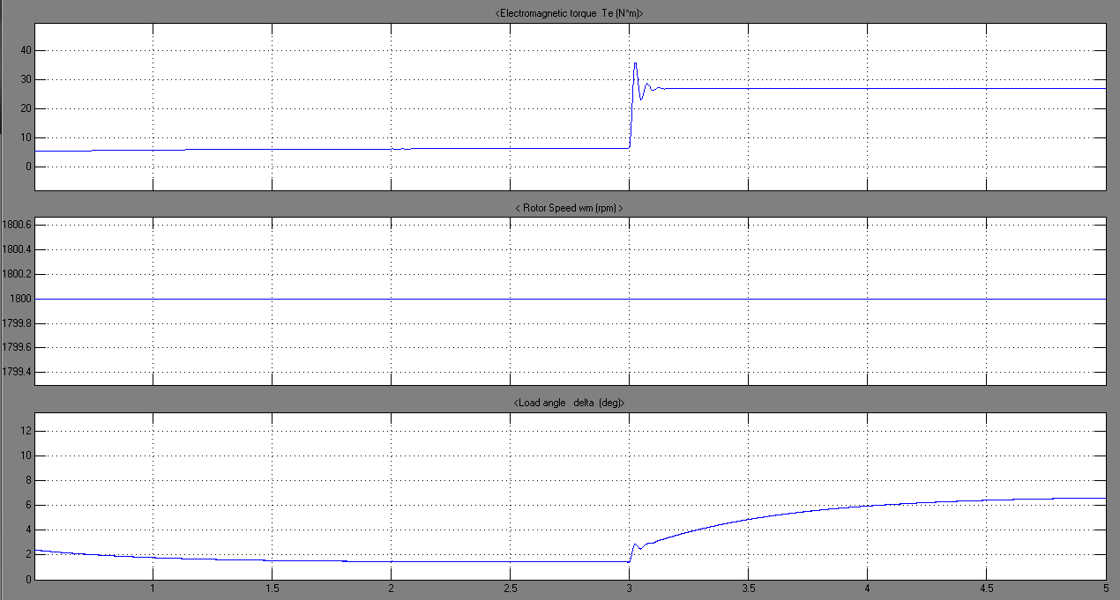

Figure 84: Electromagnetic Torque, Speed and load angle for Generator

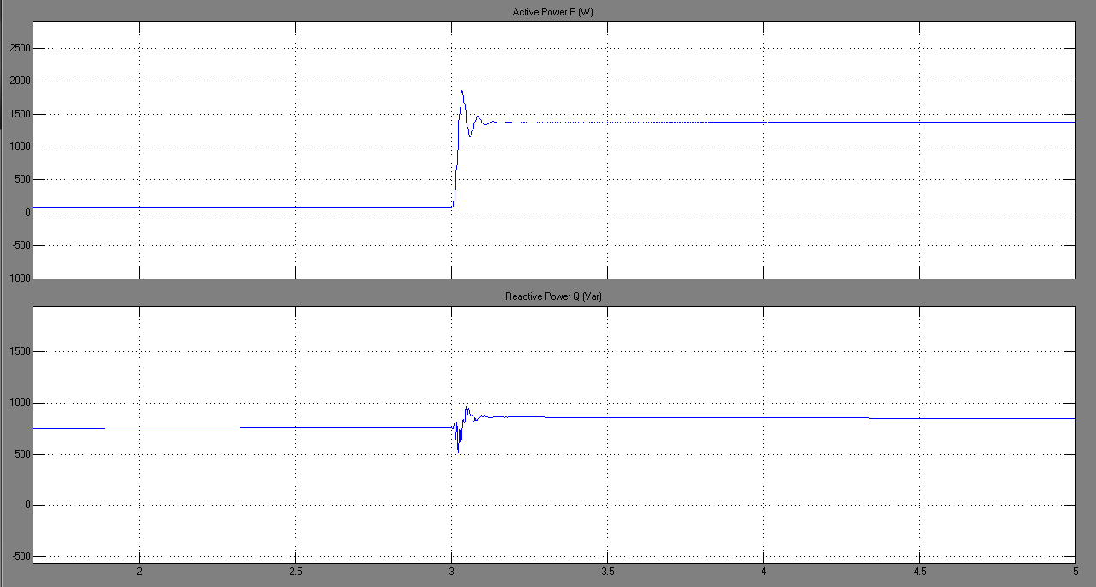

Figure 85: Active and Reactive Power consumption by the motor

### Synchronous Generator feeding induction motor for a decrease in motor speed:

During this scenario, we have considered the speed of the rotor on the motor side as the single input. The speed was initially equal to the rated value, then at t = 3 seconds, a 5% decrease was performed. Figure 86 shows the stator currents on the motor side; these currents were subject to an instantaneous increase once the speed was decreased. This is logical, since a decrease in the rotor speed will require more torque hence more current.

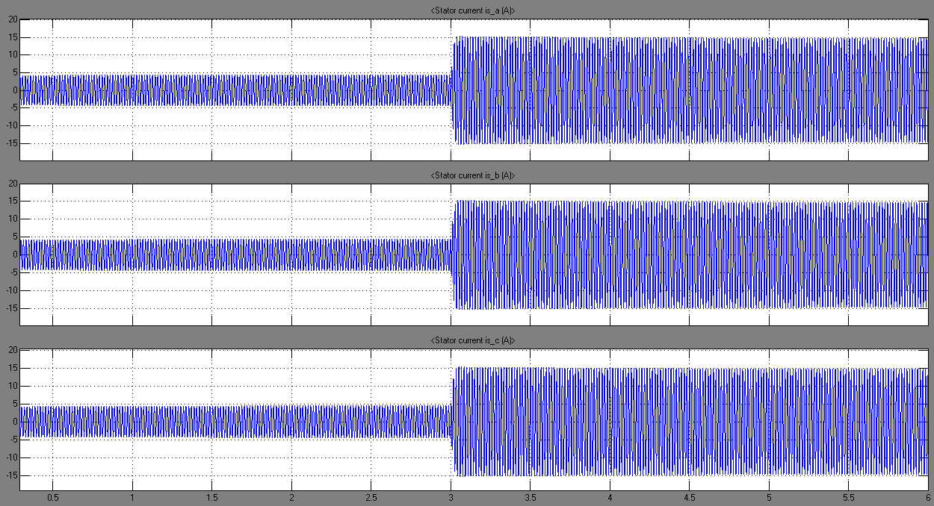

Figure 86: Stator Currents (motor side)

As for the rotor currents seen from the induction machine’s side (figure 87), an increase of these quantities was also observed as expected. Since the induction machine is an asynchronous one, certainly the stator and rotor variables won’t be synchronized.

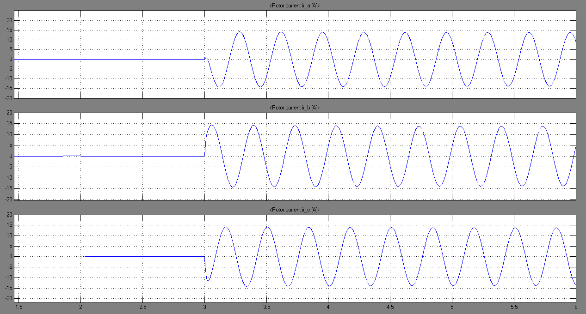

Figure 87: Rotor Currents (motor side)

As stated previously, a decrease in the speed will yield to a higher electromagnetic torque in order to compensate the slowing down of the induction motor. The electromagnetic torque characteristics were shown in figure 88. As for the speed, its change was observed in figure 89.

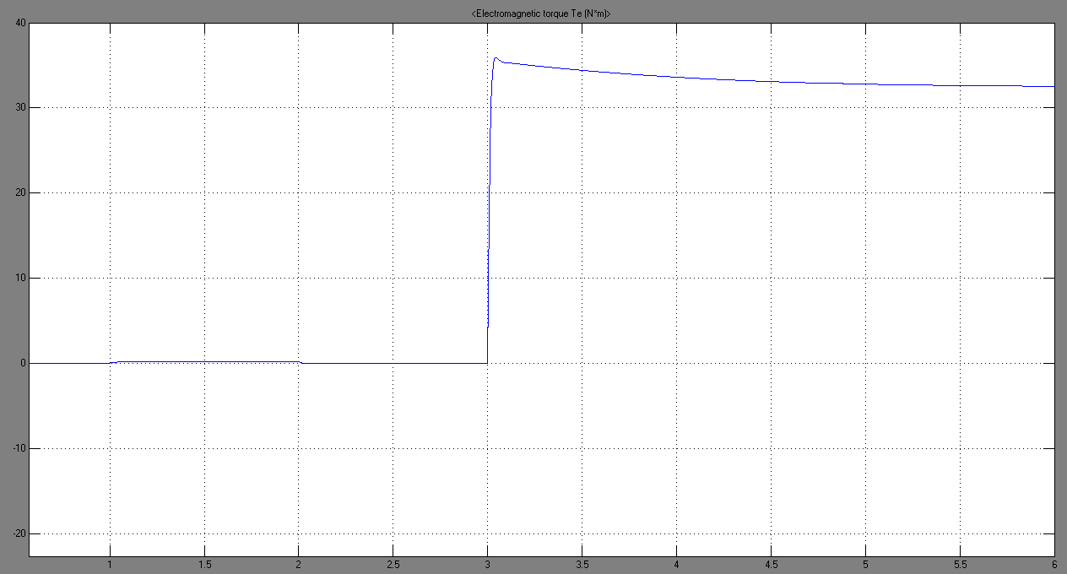

Figure 88: Electromagnetic Torque Te (motor side)

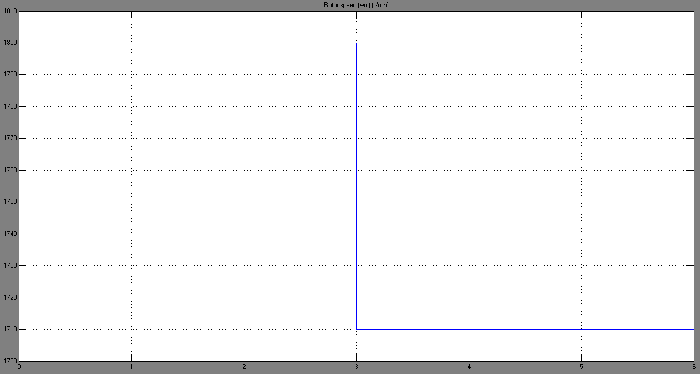

Figure 89: Rotor Speed for the motor

In what concerns the stator voltages, which were applied to both, the stator of the generator and the stator of the motor, they have been shown in figure 90 with an emphasis on the variation at the time the speed was decreased. Since a decrease in the rotor speed will require more torque, the behavior of the voltages and currents of the stators will be similar to that observed when the load torque was increased. We can clearly notice, a slight decrease in these voltages, which is due to nothing but the torque increase. Since this behavior is frequently encountered in many applications where a generator is feeding a motor (or a load), voltage regulation devices would be of great importance in order to maintain stability. However, since in our application the voltage drop has not exceeded its limit (±5%), regulators were not introduced.

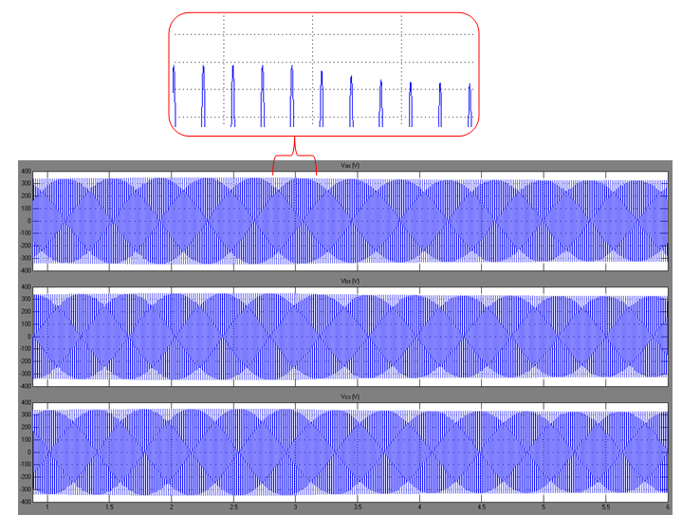

Figure 90: Stator Voltages

Figure 91 illustrates the stator currents delivered by the generator. These currents supply in addition to the induction motor, a constant load having a value of P = 1000W and Q = 100 var: . Before reduction of the speed, the currents delivered by the generator were mainly supplying the load; this can be noticed when comparing figure 86 and figure 91. Once the speed of the rotor decreased on the motor side, this induction machine will absorb more current which will be delivered from the generator. A comparison of the increase in the currents in the two machines (which is equal in quantity) at t = 3 seconds would be of interest.

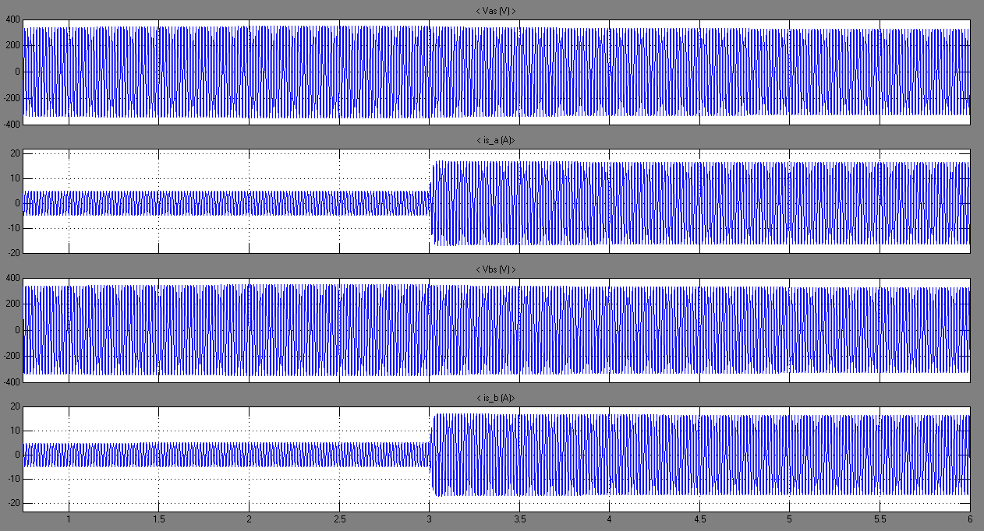

Figure 91: Stator Voltages and Currents (Generator side)

Figure 92 represents the electromagnetic torque, the rotor speed and the load angle on the generator side. Since the generator should deliver more power in order to satisfy the changes which occurred on the motor side, higher values of electromagnetic torque and load angle must be attained. The speed of the generator remained unchanged all along the simulation.

Figure 93 illustrates the active and reactive powers consumed by the induction motor. As stated previously, this motor initially absorbs reactive power. However, once the speed was decreased, more power, whether active or reactive, needed to be generated by the synchronous machine. As we can notice, the motor has absorbed more P and similarly more Q.

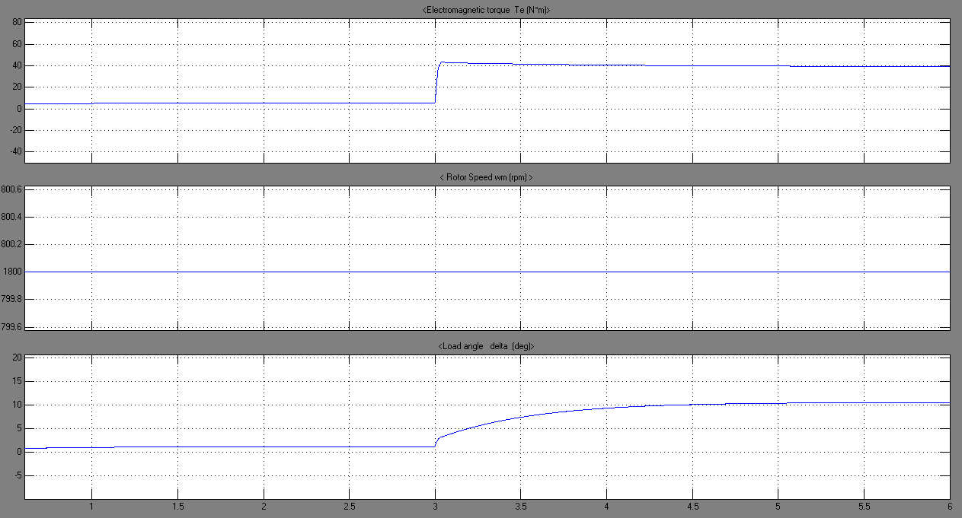

Figure 92: Electromagnetic Torque, Rotor speed and load angle

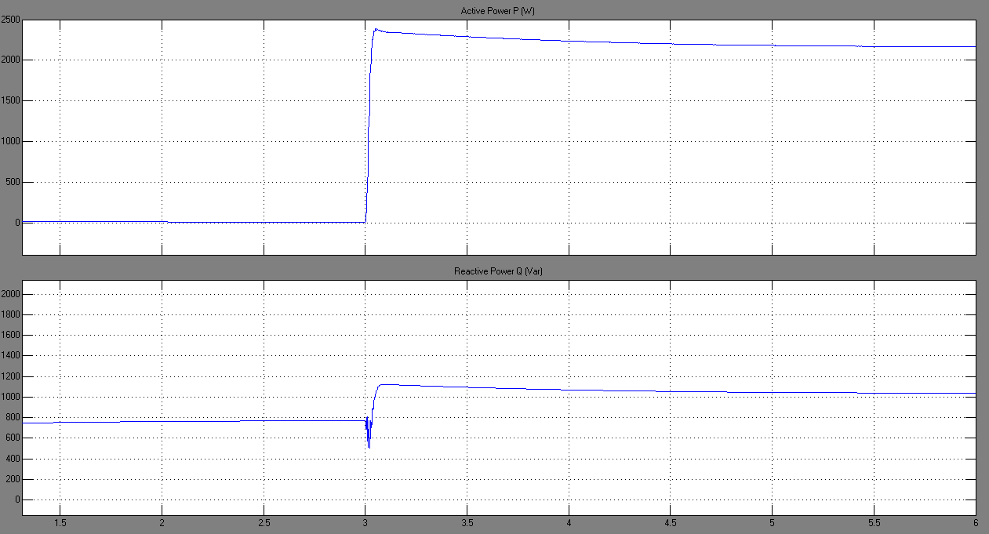

Figure 93: Active and Reactive Power absorbed by the motor

# Conclusion:

In this project, two types of machine were investigated; three-phase induction motor and a three-phase synchronous generator under balanced three-phase operation.

To analyze the symmetrical induction machine, it was necessary to incorporate a change of variables so that the resulting variables would not be in relative motion. Computer simulation was indispensable in order to observe the dynamic and steady state characteristics of the machine. The model has been simulated under various scenarios, in order to observe the changes in the machine’s characteristics.

Similarly, in order to represent and better analyze the behavior of a synchronous machine, a change of variable was incorporated. This transformation replaces the stator variables with variables associated with fictitious windings fixed in the rotor frame. In this way, the time varying stator self-inductances as well as the time-varying stator to rotor mutual inductances were eliminated and all inductances became constant. Since synchronous generators analysis consists of non-linear equations in the dynamic behavior, computer simulation was of great importance in order to interpret the various behaviors of the machine’s characteristics under various conditions.

Finally, a combined model was realized and simulated for different scenarios. This model consisted of an induction motor fed by a synchronous generator; hence, there was no need for voltage sources integration. All the results found were analyzed in details. These results do not only give meaning to the dynamic behavior of each machine, but they also set the stage for studying the dynamic characteristics of a power system containing hundreds of such machines.

# Table of figures:

Figure 1: A two-pole three-phase symmetrical induction machine 5

Figure 2: Induction motor parameters 9

Figure 3: Simulink diagram for Free Acceleration Scenario 10

Figure 4: Stator Voltages 11

Figure 5: Stator Currents 11

Figure 6: Rotor Currents 12

Figure 7: Electromagnetic Torque 13

Figure 8: Rotor Speed (r/min) 14

Figure 9: Torque vs Speed characteristic during free acceleration 15

Figure 10: Rotor Currents, Stator Current and Voltages in stationary reference frame 16

Figure 11: Simulink diagram for an acceleration form stall with load torque 17

Figure 12: Stator voltages 18

Figure 13: Stator Currents 19

Figure 14: Rotor Currents 19

Figure 15: Rotor Currents, Stator Currents and Voltages in stationary reference frame 20

Figure 16: Electromagnetic Torque Te 21

Figure 17: Rotor speed wm 21

Figure 18: Torque versus Speed during acceleration 22

Figure 19: Simulink diagram Step Changes in Load Torque 23

Figure 20: Stator voltages 24

Figure 21: Stator Currents 25

Figure 22: Rotor Currents 25

Figure 23: Rotor Currents, Stator Currents and voltages in stationary reference frame 26

Figure 24: Electromagnetic Torque Te 27

Figure 25: Rotor Speed wm 27

Figure 26: Load Torque TL 28

Figure 27: Simulink diagram of a Step in frequency 29

Figure 28: Stator Voltages 30

Figure 29: Stator Currents 30

Figure 30: Rotor Currents 31

Figure 31: Rotor Currents, Stator Currents and voltages in stationary reference frame 31

Figure 32: Electromagnetic Torque Te 32

Figure 33: Rotor Speed 32

Figure 34: Torque versus Speed for Step Change in stator frequency 33

Figure 35: Simulink diagram for a step change in stator voltage magnitudes 34

Figure 36: Stator Voltages 35

Figure 37: Stator Currents 36

Figure 38: Rotor Currents 37

Figure 39: Rotor Currents, Stator Currents and voltages in stationary reference frame 37

Figure 40: Electromagnetic Torque Te 38

Figure 41: Rotor Speed 38

Figure 42: Torque versus Speed characteristics for different stator voltage magnitudes 39

Figure 43: Simulink diagram for Synchronous Generator 46

Figure 44: Stator Voltages and Currents 47

Figure 45: Torques, Speed and load angle 48

Figure 46: Torques, Speed and load angle 49

Figure 47: Voltages and Currents in the Rotor reference frame 50

Figure 48: Stator Voltages and Currents at Steady state 50

Figure 49: Torques, speed and load angle at steady state 51

Figure 50: Torques, speed and load angle at steady state 51

Figure 51: Torque versus rotor angle characteristics (dynamic and steady state operation) 52

Figure 52: Stator Voltages and Currents 53

Figure 53: Torques, Speed and load angle 54

Figure 54: Torques, Speed and load angle 55

Figure 55: Torques, speed and load angle at steady state 55

Figure 56: Stator Voltages and Currents 56

Figure 57: Torques, Speed and load angle 57

Figure 58: Torques, Speed and load angle 58

Figure 59: Simulink diagram for a step change in speed 59

Figure 60: Stator Voltages and Currents 60

Figure 61: Electromagnetic Torque, Speed and load angle 61

Figure 62: Electromagnetic Torque, Speed and load angle 61

Figure 63: Currents and voltages in Rotor reference frame 62

Figure 64: Simulink diagram for a change in load 63

Figure 65: Stator Voltages and Currents 64

Figure 66: Torque, Speed and load angle 65

Figure 67: Torque, Speed and load angle 65

Figure 68: Stator Voltages and Currents 66

Figure 69: Torques, speed and load angle 67

Figure 70: Torques, speed and load angle 67

Figure 71: Voltages and Currents in rotor reference frame 68

Figure 72: Stator Voltages and Currents 69

Figure 73: Torques, speed and load angle 69

Figure 74: Torques, speed and load angle 70

Figure 75: Voltages and Currents in rotor reference frame 70

Figure 76: Simulink diagram for the combined Generator-Motor model 71

Figure 77: Load Torque TL 72

Figure 78: Stator Currents (motor side) 73

Figure 79: Rotor Currents (motor side) 73

Figure 80: Electromagnetic Torque Te (motor side) 74

Figure 81: Rotor Speed (r/min) 75

Figure 82: Stator Voltages 76

Figure 83: Generator Stator Voltages and Currents 77

Figure 84: Electromagnetic Torque, Speed and load angle for Generator 78

Figure 85: Active and Reactive Power consumption by the motor 78

Figure 86: Stator Currents (motor side) 79

Figure 87: Rotor Currents (motor side) 80

Figure 88: Electromagnetic Torque Te (motor side) 80

Figure 89: Rotor Speed for the motor 81

Figure 90: Stator Voltages 82

Figure 91: Stator Voltages and Currents (Generator side) 83

Figure 92: Electromagnetic Torque, Rotor speed and load angle 84

Figure 93: Active and Reactive Power absorbed by the motor 84

# References:

[1] Krause, P.C. andO. Wasynczuk, *Electromechanical Motion Devices*, MacGraw-Hill, 1989.

[2] Krause, P.C., O. Wasynczuk, and S.D. Sudhoff, *Analysis of Electric Machinery*, IEEE Press, 2002.

[3] Kamwa, I., et al., "Experience with Computer-Aided Graphical Analysis of Sudden-Short-Circuit Oscillograms of Large Synchronous Machines," *IEEE Transactions on Energy Conversion*, Vol. 10, No. 3, September 1995.